E-Learning management system

By

Patel Bansari Tusharbhai (24MCA055)

Trivedi Aditya Samirkumar (24MCA113)

Under Guidance

of

Internal Guide

Mr. Kaushal gor

Submitted to



Smt. Chandaben Mohanbhai Patel

Institute of Computer Applications

April, 2024



[Accredited with Grade A+ by NAAC,](https://www.charusat.ac.in/)

CHAROTAR UNIVERSITY OF SCIENCE AND TECHNOLOGY

**Acknowledgement**

Knowledge in itself is a continuous process. At this moment of our substantial enhancement, We rarely find words to express our gratitude towards those who were constantly involved with us.

The completion of any inter disciplinary project depends upon coordination, cooperation and combined efforts of several resources of knowledge, creativity, skill, energy and time. The work being accomplished now, we feel our sincerest urge to recall and knowledge through these lines, trying our best to give full credit wherever it deserves.

We would like to thank our project guide **Mr. Kaushal Gor,** I/C Principal **Dr. Dharmendra Patel** and I/C Dean **Dr. Sanskruti Patel** who advised and gave us moral support through the duration of our project. Without their constant encouragement we could not have been able to achieve what we have.

It’s our good fortune that we had support and well wishes of many. We are thankful to all and those names which have been forgotten to acknowledge here but contributions have not gone unnoticed.

With Sincere Regards,

**Patel Bansari (24MCA055)**

**Trivedi Aditya (24MCA113)**

|  |  |  |  |
| --- | --- | --- | --- |
| **Sr. No** |  | **Subject** | **Page Number** |
| **1** |  | **Project Profile** | **4 - 5** |
| **2** |  | **Introduction to tools** | **6 - 7** |
| **3** |  | **System Study** | **8** |
|  |  | Existing System | 9 |
|  |  | Proposed System | 9 |
|  |  | Scope of the Proposed System | 9 |
|  |  | Aim and Objective of the Proposed System | 9 |
|  |  | Feasibility Study | 9 - 10 |
|  |  | Technical Feasibility | 9 |
|  |  | Economical Feasibility | 9 |
|  |  | Operational Feasibility | 10 |
| **4** |  | **System Analysis** | **11** |
|  |  | Requirements Specification (along with System Modules) | 12 |
|  |  | Use Case Diagram | 13 - 15 |
|  |  | Activity Diagram | 16 - 18 |
|  |  | Class Diagram | 19 |
| **5** |  | **System Design** | **20** |
|  |  | Data Dictionary | 21 - 25 |
|  |  | Screen Layouts | 26 - 58 |
| **6** |  | **System Testing** | **59** |
|  |  | Test Cases | 60 |
| **7** |  | Future Enhancement | **61 - 62** |
| **8** |  | Bibliography/References | **63 - 64** |
| **9** |  | Reporting Report (to be collected from respective internal guide) | **67** |

**Table of Content**

Project Profile

* ***Project Profile***
* **Project Name :** E-Learning Management System
* **Type of Application :** Website
* **Project Description :** ELMS is a web-based platform designed to facilitate seamless interaction between students, teachers, and administrators in a virtual academic environment. It includes course enrollment, content delivery, assignment submission & quiz handling (future enhancement), resume-based teacher recruitment, and password reset via email
* **Team Size :** 2 Members
* **Front End :** HTML, CSS, JAVASCRIPT, BOOTSTRAP
* **Back End :** PYTHON (Django) & SQLite3
* **Tools used :** PyCharm, VS CODE

Introduction to tools

* ***Introduction to Tools***
* **Front End Tool :** HTML, CSS, JAVASCRIPT, BOOTSTRAP & jQuery.

HTML, CSS, JavaScript and Bootstrap are generally used for creating beautiful and creative responsive websites, web developments. As bootstrap framework is for faster and easier web development. Bootstrap includes HTML and CSS frameworks, therefore it gives us the readymade design templates for typography, forms, image carousels, tables, navigations and many other, as well as optional JavaScript plugins. JavaScript is basically used for applying the basic functionalities to any website/web-development. jQuery is a lightweight JavaScript library. The purpose of jQuery is to make it much easier to use JavaScript on your website.

* **Back End Tool :** PYTHON & SQLite3
* **PYTHON :** Python is a high-level, interpreted, and object-oriented programming language known for its simplicity and readability. Django is a full-stack web framework built on Python that follows the MTV (Model-Template-View) architecture. It provides built-in features for routing, templating, authentication, and database management, making backend development faster and more secure.
* **SQLite3**:  
  SQLite3 is the default lightweight, file-based database engine used by Django during development. It requires no separate server process and stores the entire database as a single file on disk. It is ideal for small to medium-sized projects and rapid prototyping.

System Study

* ***System Study***
* **Existing System :**
* In the traditional academic environment, **students, teachers, and administrators interact manually** or via disparate systems.
* Course materials, assignments, communications etc, are often **shared through email, physical copies, or fragmented platforms**, leading to inefficiencies.
* There is **no centralized system** to manage courses, submissions, recruitment, or notifications.
* Teacher recruitment is typically handled **offline or via separate portals**, with limited integration into the academic system.
* **Proposed System :**
* The proposed E-Learning Management System (ELMS) is a centralized web-based platform that integrates core academic functions into a single portal.
* It allows:
  + Students to enroll in courses, access video materials.
  + Teachers to manage content, and view their earnings.
  + Administrators to oversee platform usage, manage users, and handle recruitment.
* The system also supports resume-based teacher recruitment and automated email notifications for password reset.
* **Scope of the Proposed System :**
* The system serves as an **interactive bridge** between **Students, Teachers, and Administrators**.
  + It covers:
  + Course management
  + Content delivery
  + Resume-based recruitment
  + Password reset via email
  + (Future scope: Quiz & Assignment handling)
* **Aim and Objective of the Proposed System :**
  + To **digitize the academic workflow**, making learning accessible from anywhere.
  + To **simplify student-teacher communication** and resource sharing.
  + To **centralize operations** like course handling, submissions, and recruitment.
  + To **save time** and improve efficiency for all users in the academic environment.
  + To create a **user-friendly and scalable system** that can be enhanced with additional features in the future.
* **Feasibility Study :**
* **Technical Feasibility:**
  + The system is built using **Python (Django)** and **SQLite3**, which are both **open-source and well-supported**.
  + These technologies are sufficient to develop a functional prototype without the need for heavy infrastructure.
  + The system is deployable on **cross-platform environments** like Windows, Linux, or cloud-based servers.
* **Economic Feasibility:**
  + Since the tools used (Python, Django, SQLite3, Bootstrap, VS Code, PyCharm Community Edition) are **free or open-source**, the cost of development is minimal.
  + Hosting and deployment costs are manageable, especially on low-cost platforms or educational hosting services.
  + The system can be used by multiple institutions, making it scalable and **cost-effective in the long run**.
* **Operational Feasibility:**
  + The portal is designed with **ease of use in mind**, requiring minimal training for students, teachers, and admins.
  + Backend operations are managed using Django’s built-in admin interface.
  + User roles and permissions ensure smooth and **secure workflow** management across different user types.

System Analysis

* ***System Analysis***
* **Requirement Specifications :**
* **FOR DEVELOPERS :**

|  |  |
| --- | --- |
| RAM : | Minimum 4GB RAM |
| Hard Disk : | Minimum 128GB ROM |
| Processor : | **Intel Core i5** or higher (recommended) |

* **SOFTWARE SPECIFICATON :**

|  |  |  |  |
| --- | --- | --- | --- |
| Operating System : | |  | | --- | |  |  |  | | --- | | Windows OS / Linux / macOS (cross-platform compatibility) | |
| Editor : | PyCharm |
| Web Browser : | Google Chrome (recommended for testing and debugging) |
| Front End Tool : | HTML, CSS, JS, BOOTSTRAP, jQuery |
| Back End Tool : | Python (Django Framework) |
| DataBase: | SQLite3 (default database in Django) |
| Web Server: | Django’s built-in development server (for testing) |

* **FOR USER :**

|  |  |
| --- | --- |
| RAM : | Minimum 4GB RAM (recommended) |
| Storage : | Minimum 128GB ROM |
| Web Browser: | Any modern browser (Chrome, Firefox, Edge, etc.) |
| Internet | |  | | --- | |  |  |  | | --- | | Stable internet connection (for accessing the platform online) | |
| Software | |  | | --- | |  |  |  | | --- | | No installation required, Accessible via browser | |

* **Use Case Diagram :**

**ADMIN:**

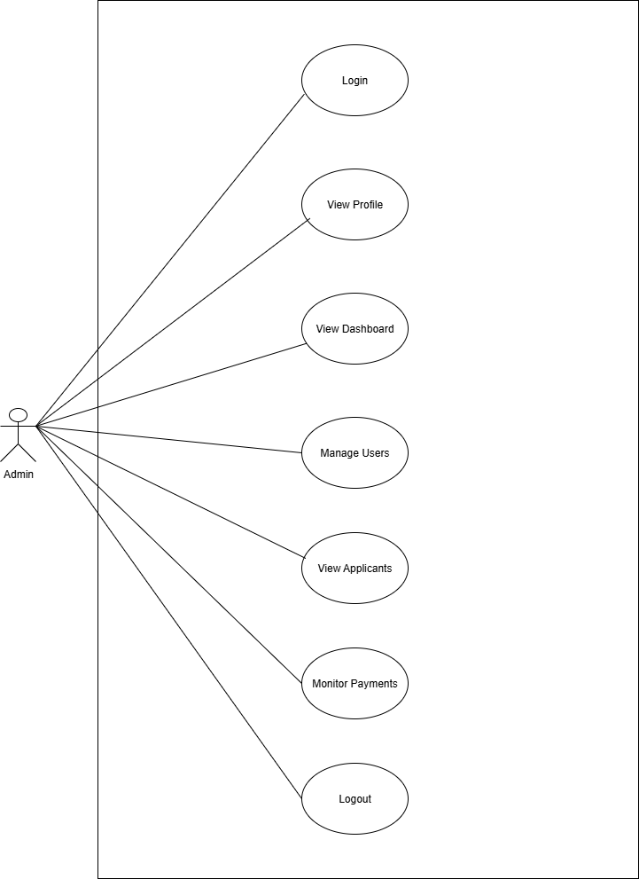

**TEACHER:**

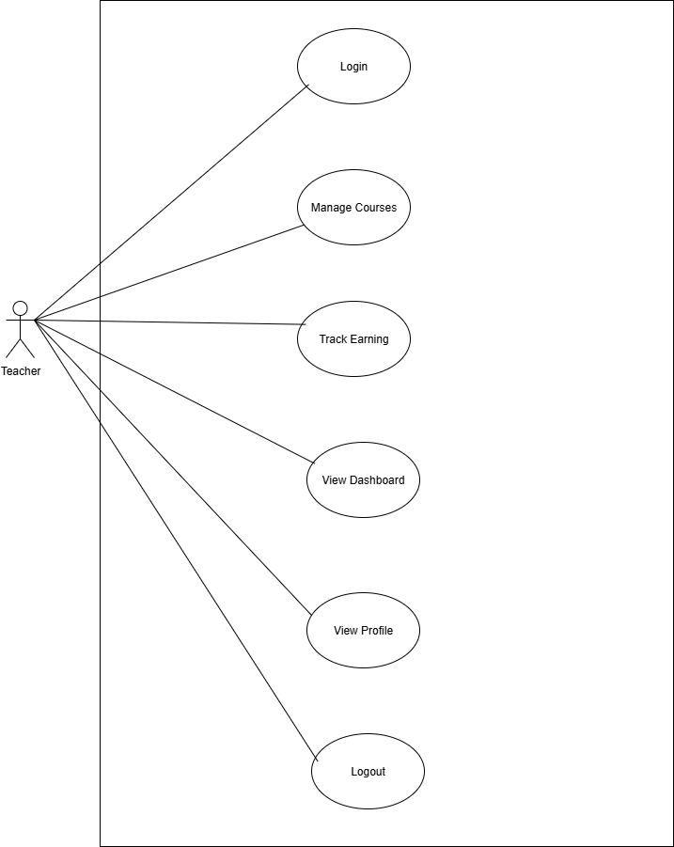

**STUDENT:**

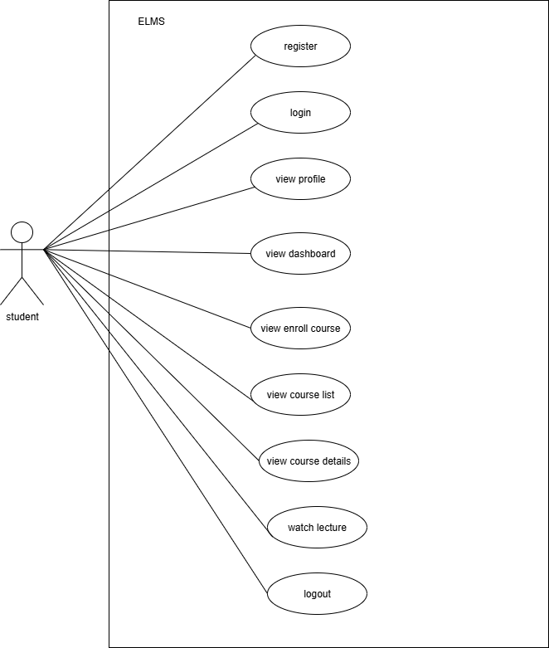

* **Activity Diagram :**
* ADMIN :

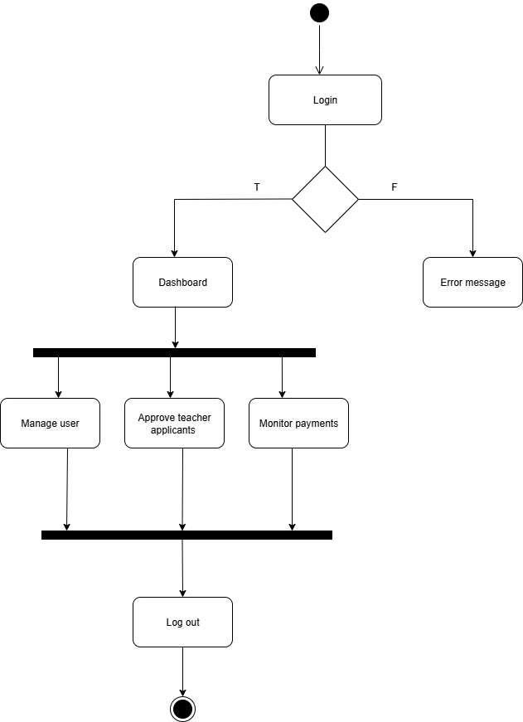

* STUDENT:

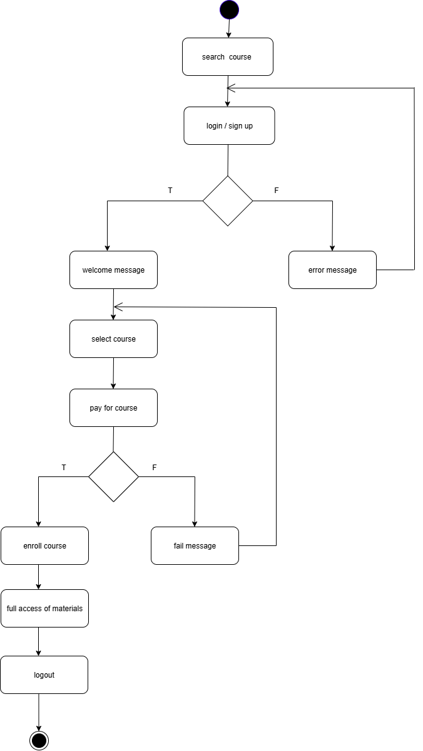

* TEACHER

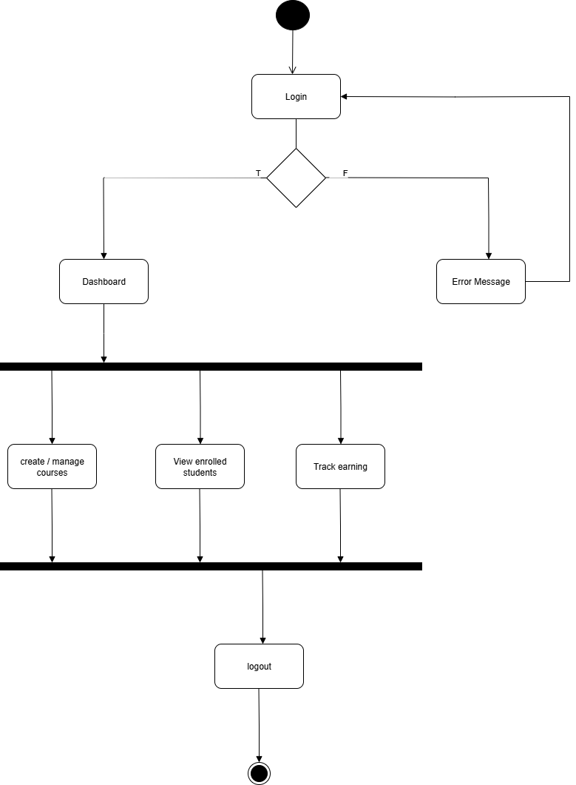

* **Class Diagram :**

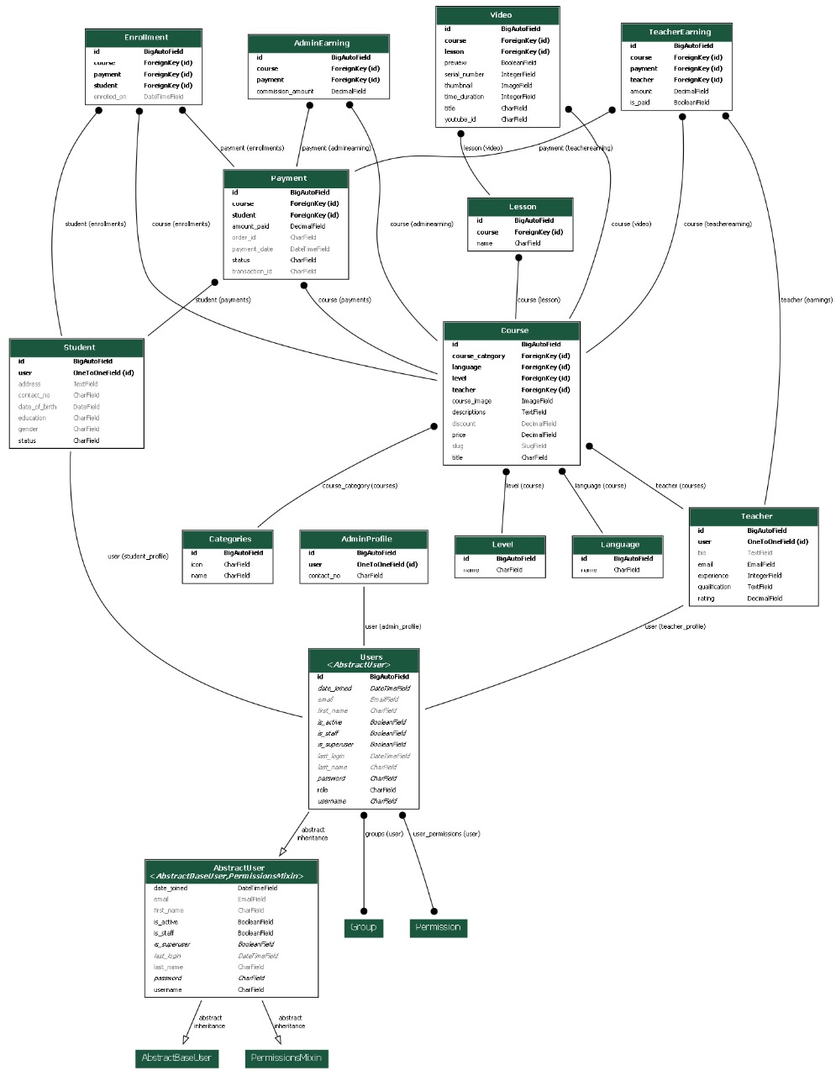

System Design

* ***System Designs***
* **Data Dictionary :**
* **Table Name :** **Users**

|  |  |  |  |
| --- | --- | --- | --- |
| **Field** | **Type** | **Key** | **Description** |
| id | INT | PK | Unique identifier for each user |
| username | VARCHAR(150) | UNIQUE | Login username |
| email | VARCHAR(255) | UNIQUE | User email address |
| password | VARCHAR(255) |  | Hashed password |
| role | ENUM('student','teacher','admin') |  | Defines user role |

* **Table Name :** **Student**

|  |  |  |  |
| --- | --- | --- | --- |
| **Field** | **Type** | **Key** | **Description** |
| id | INT | PK | Unique identifier for each student |
| user_id | INT | FK | Links to Users.id |
| contact_no | VARCHAR(20) |  | Student contact number |
| address | TEXT |  | Residential address |
| date_of_birth | DATE |  | Birth date |
| gender | ENUM  ('Male','Female','Other') |  | Gender of student |
| education | VARCHAR(200) |  | Education qualification |
| status | ENUM  ('active','inactive') |  | Active/inactive status |

* **Table Name :** **teacher**

|  |  |  |  |
| --- | --- | --- | --- |
| **Field** | **Type** | **Key** | **Description** |
| id | INT | PK | Unique identifier for each teacher |
| user_id | INT | FK | Links to Users.id |
| email | VARCHAR(255) |  | Teacher email |
| qualification | TEXT |  | Academic qualification |
| experience | INT |  | Years of teaching experience |
| rating | DECIMAL(3,2) |  | Teacher rating |
| bio | TEXT |  | Short biography |

## **Table Name : AdminProfile**

|  |  |  |  |
| --- | --- | --- | --- |
| **Field** | **Type** | **Key** | **Description** |
| id | INT | PK | Unique identifier for each admin profile |
| user_id | INT | FK | Links to Users.id |
| contact_no | VARCHAR(20) |  | Admin contact number |

## **Table Name : Categories**

|  |  |  |  |
| --- | --- | --- | --- |
| **Field** | **Type** | **Key** | **Description** |
| id | INT | PK | Unique identifier for each category |
| name | VARCHAR(200) |  | Category name |
| icon | VARCHAR(200) |  | Category icon name |

## **Table Name : Level**

|  |  |  |  |
| --- | --- | --- | --- |
| **Field** | **Type** | **Key** | **Description** |
| id | INT | PK | Unique identifier for each level |
| name | VARCHAR(200) |  | Level name |

## **Table Name : Language**

|  |  |  |  |
| --- | --- | --- | --- |
| **Field** | **Type** | **Key** | **Description** |
| id | INT | PK | Unique identifier for each language |
| name | VARCHAR(200) |  | Language name |

## **Table Name : Course**

|  |  |  |  |
| --- | --- | --- | --- |
| **Field** | **Type** | **Key** | **Description** |
| id | INT | PK | Unique identifier for each course |
| course_image | VARCHAR(255) |  | Course image path |
| teacher_id | INT | FK | Links to Teacher.id |
| title | VARCHAR(255) |  | Course title |
| descriptions | TEXT |  | Detailed course description |
| course_category | INT | FK | Links to Categories.id |
| level_id | INT | FK | Links to Level.id |
| language_id | INT | FK | Links to Language.id |
| slug | VARCHAR(500) | UNIQUE | SEO friendly URL |
| price | DECIMAL(10,2) |  | Course price |
| discount | DECIMAL(5,2) |  | Discount on course |

## **Table Name : Lesson**

|  |  |  |  |
| --- | --- | --- | --- |
| **Field** | **Type** | **Key** | **Description** |
| id | INT | PK | Unique identifier for each lesson |
| course_id | INT | FK | Links to Course.id |
| name | VARCHAR(200) |  | Lesson title |

## **Table Name : Video**

|  |  |  |  |
| --- | --- | --- | --- |
| **Field** | **Type** | **Key** | **Description** |
| id | INT | PK | Unique identifier for each video |
| serial_number | INT |  | Order number of video |
| thumbnail | VARCHAR(255) |  | Video thumbnail path |
| course_id | INT | FK | Links to Course.id |
| lesson_id | INT | FK | Links to Lesson.id |
| title | VARCHAR(200) |  | Video title |
| youtube_id | VARCHAR(200) |  | YouTube video identifier |
| time_duration | INT |  | Length of video in minutes |
| preview | BOOLEAN |  | Is video free preview? |

## **Table Name : Payment**

|  |  |  |  |
| --- | --- | --- | --- |
| **Field** | **Type** | **Key** | **Description** |
| id | INT | PK | Unique identifier for each payment |
| student_id | INT | FK | Links to Student.id |
| course_id | INT | FK | Links to Course.id |
| amount_paid | DECIMAL(10,2) |  | Amount paid |
| status | ENUM('successful','failed') |  | Payment status |
| payment_date | DATETIME |  | Date of payment |
| transaction_id | VARCHAR(255) |  | Transaction reference ID |
| order_id | VARCHAR(255) |  | Order reference ID |

## **Table Name: Enrollment**

|  |  |  |  |
| --- | --- | --- | --- |
| **Field** | **Type** | **Key** | **Description** |
| id | INT | PK | Unique identifier for enrollment |
| student_id | INT | FK | Links to Student.id |
| course_id | INT | FK | Links to Course.id |
| payment_id | INT | FK | Links to Payment.id |
| enrolled_on | DATETIME |  | Enrollment date |

## **Table Name: TeacherEarning**

|  |  |  |  |
| --- | --- | --- | --- |
| **Field** | **Type** | **Key** | **Description** |
| id | INT | PK | Unique identifier for earning record |
| teacher_id | INT | FK | Links to Teacher.id |
| course_id | INT | FK | Links to Course.id |
| payment_id | INT | FK | Links to Payment.id |
| amount | DECIMAL(10,2) |  | Earning amount |
| is_paid | BOOLEAN |  | Whether earning is paid |

## **Table Name: AdminEarning**

|  |  |  |  |
| --- | --- | --- | --- |
| **Field** | **Type** | **Key** | **Description** |
| id | INT | PK | Unique identifier for commission record |
| course_id | INT | FK | Links to Course.id |
| payment_id | INT | FK | Links to Payment.id |
| commission_amount | DECIMAL(10,2) |  | Admin commission amount |

* **Screen Layouts :**
* INDEX

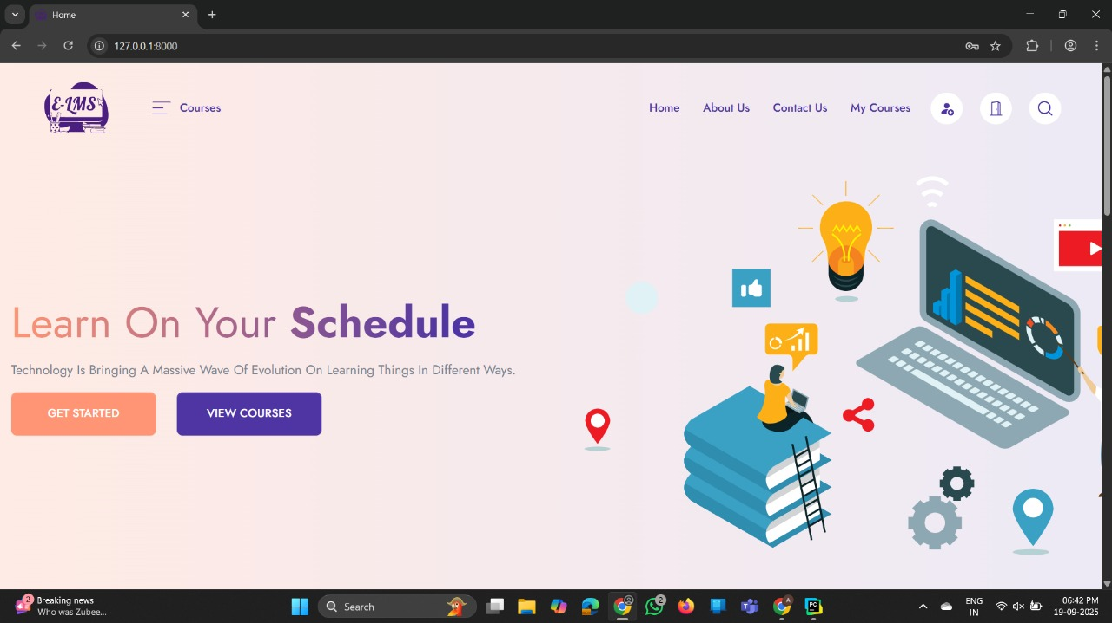

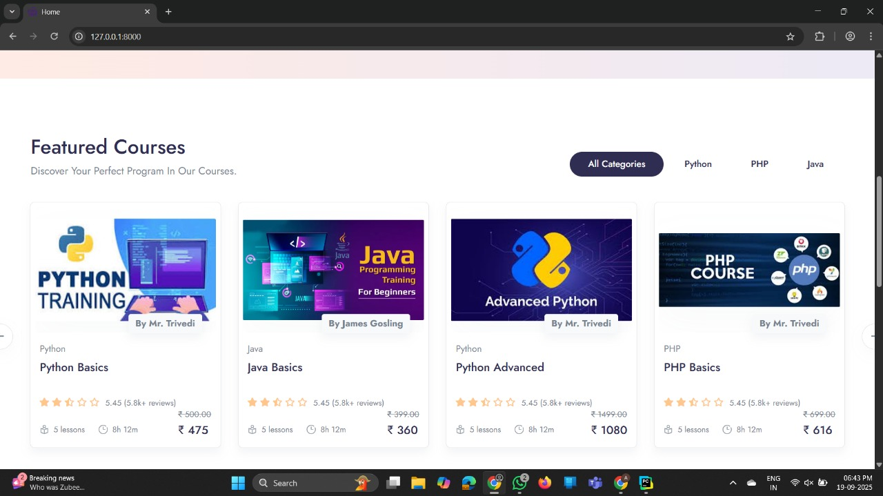

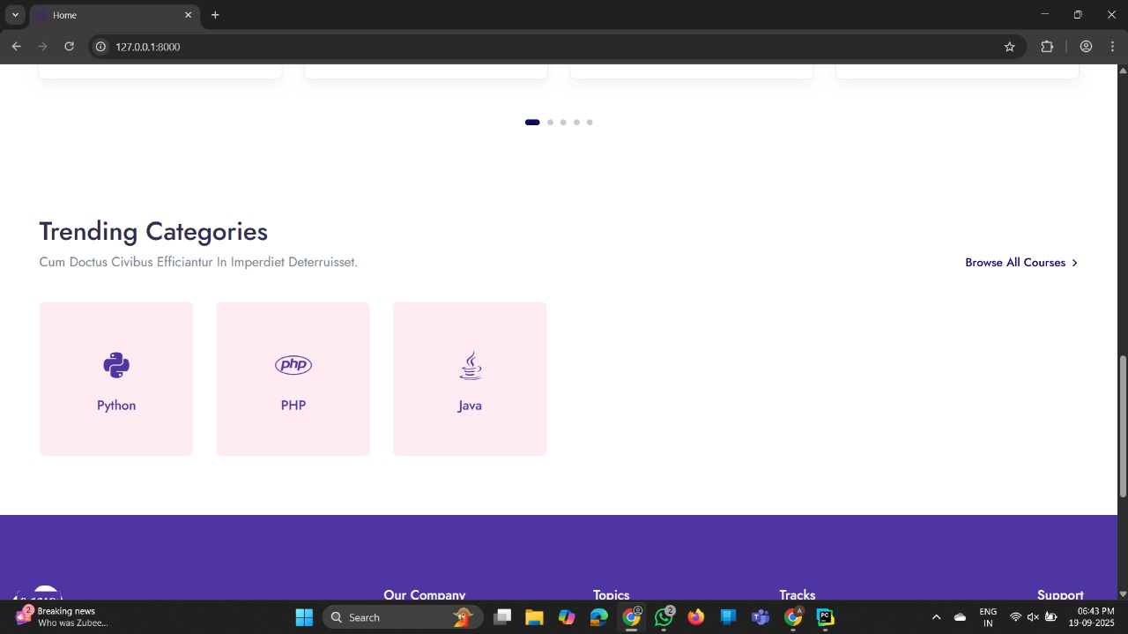

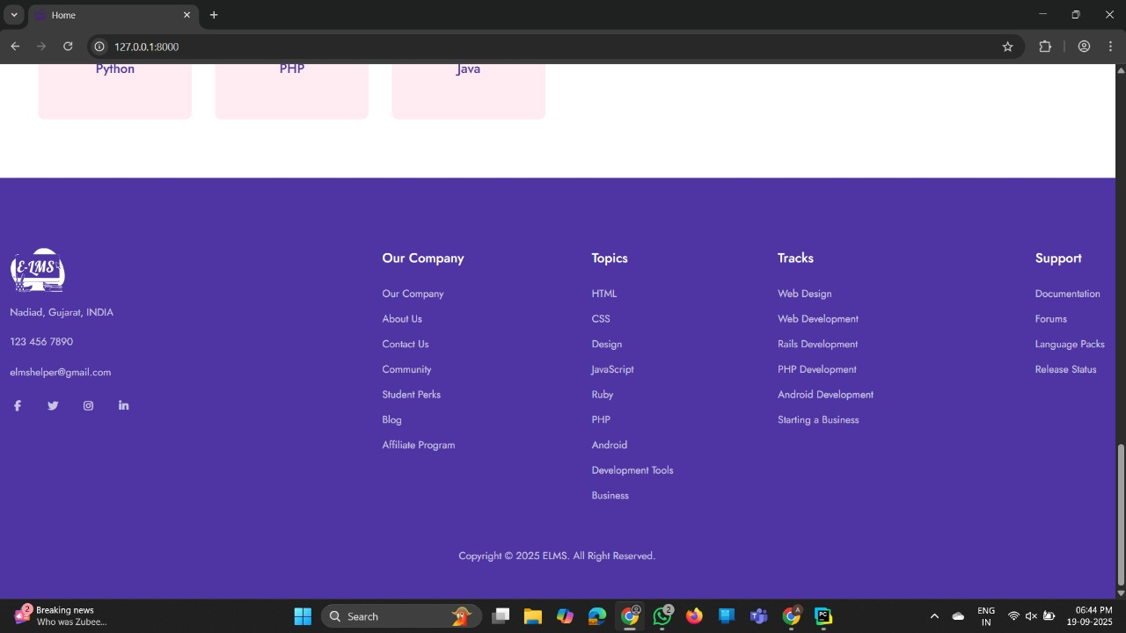

* ABOUT US:

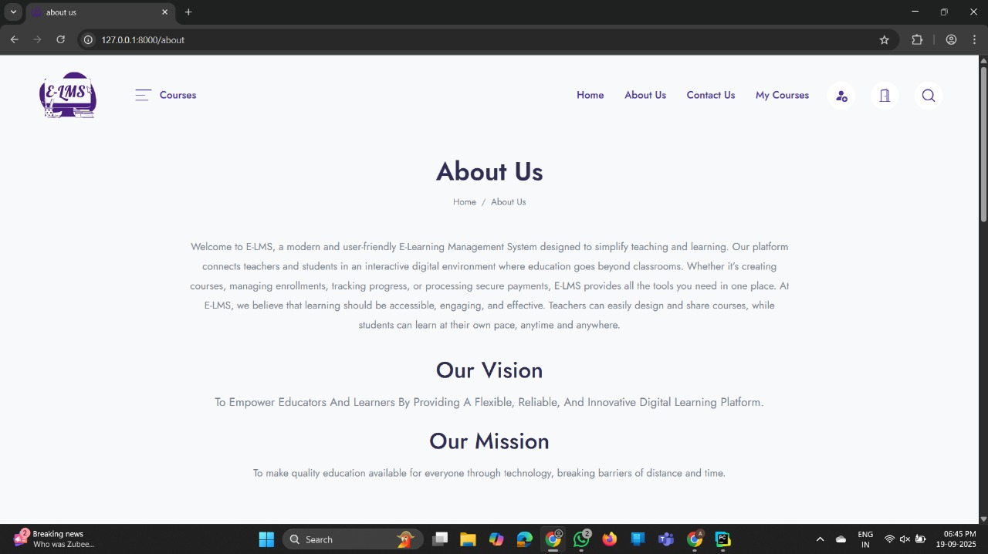

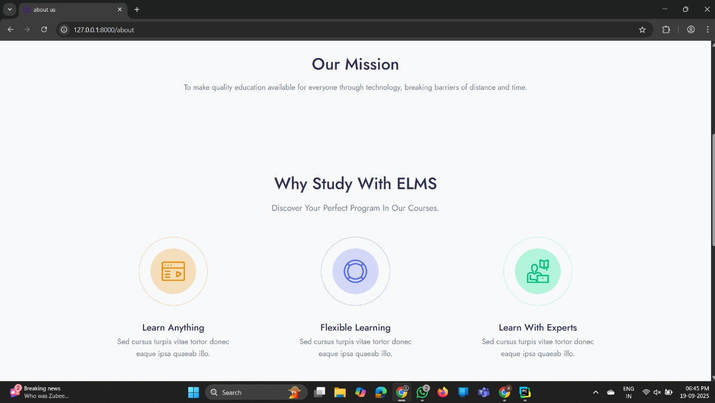

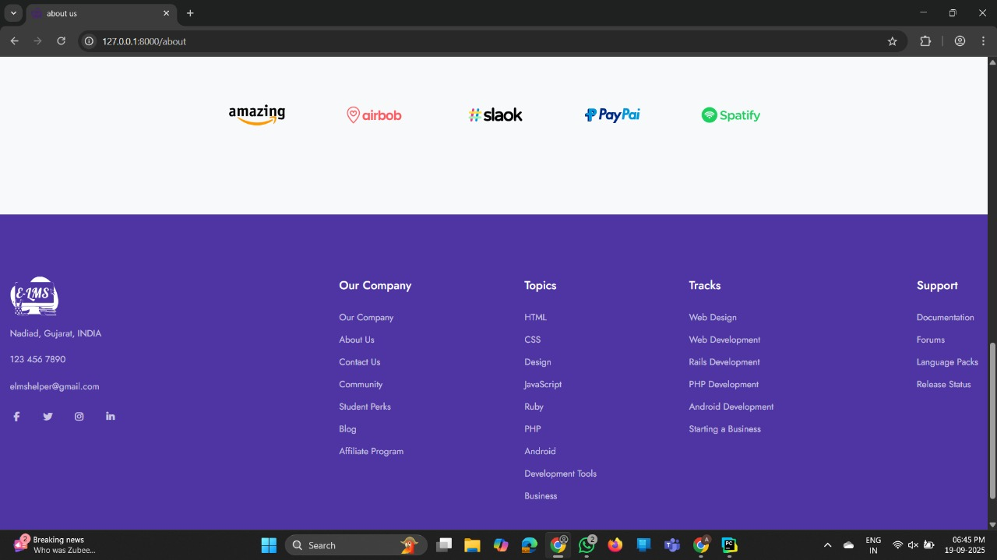

* CONTACT:

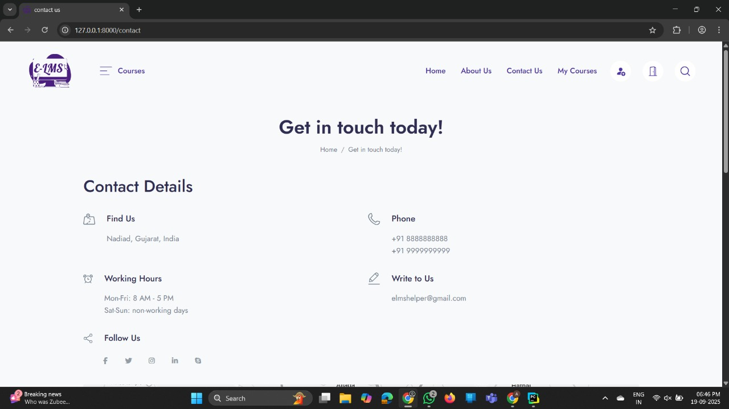

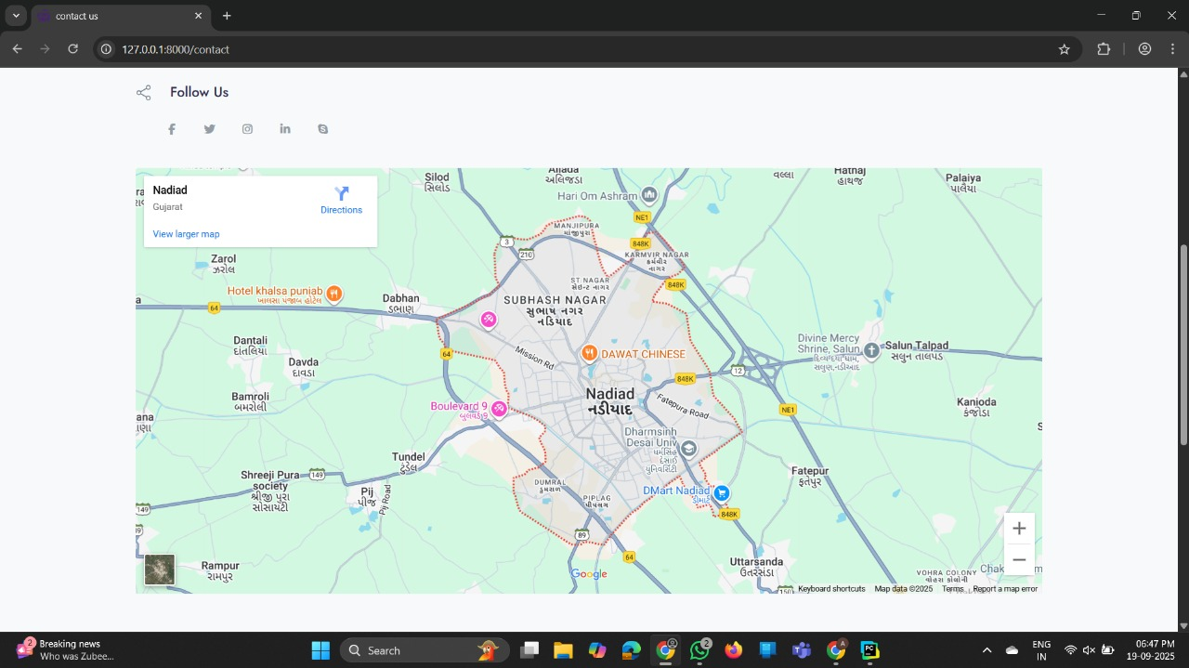

* INDEX_SEARCH:

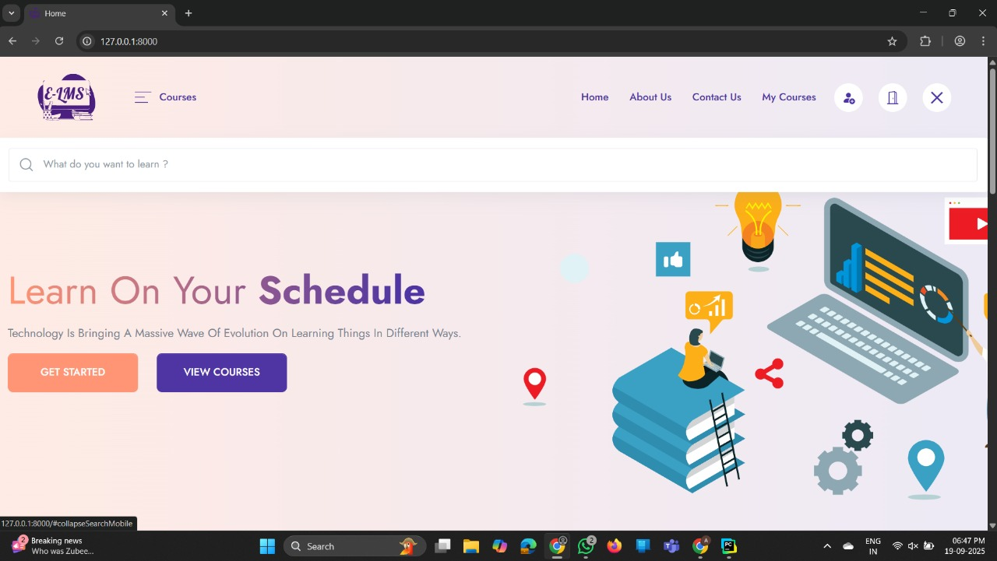

* REGISTER:

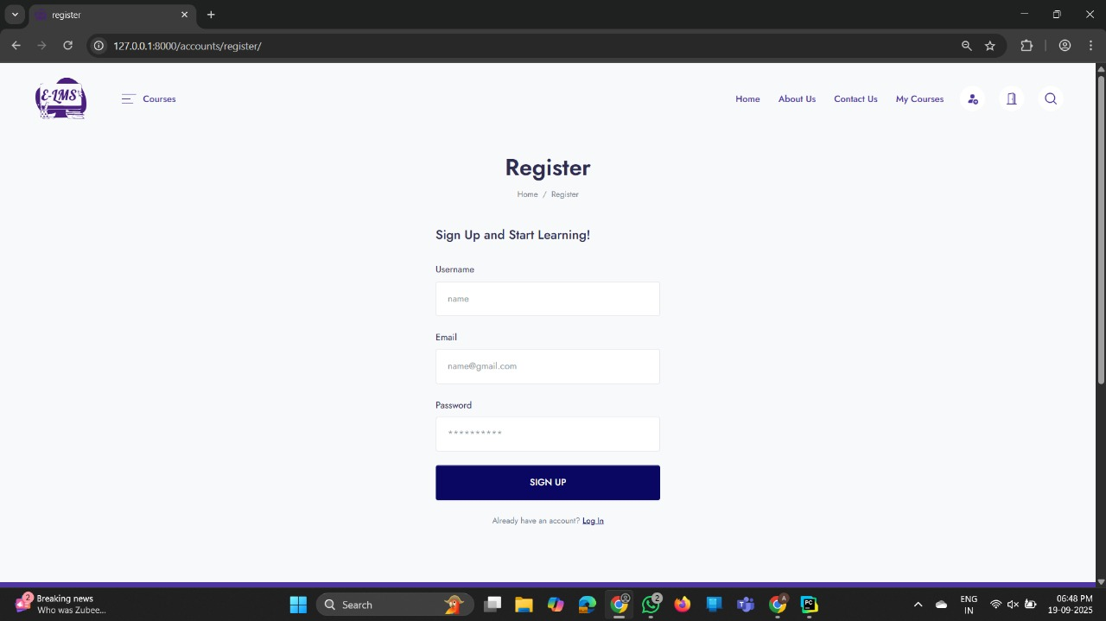

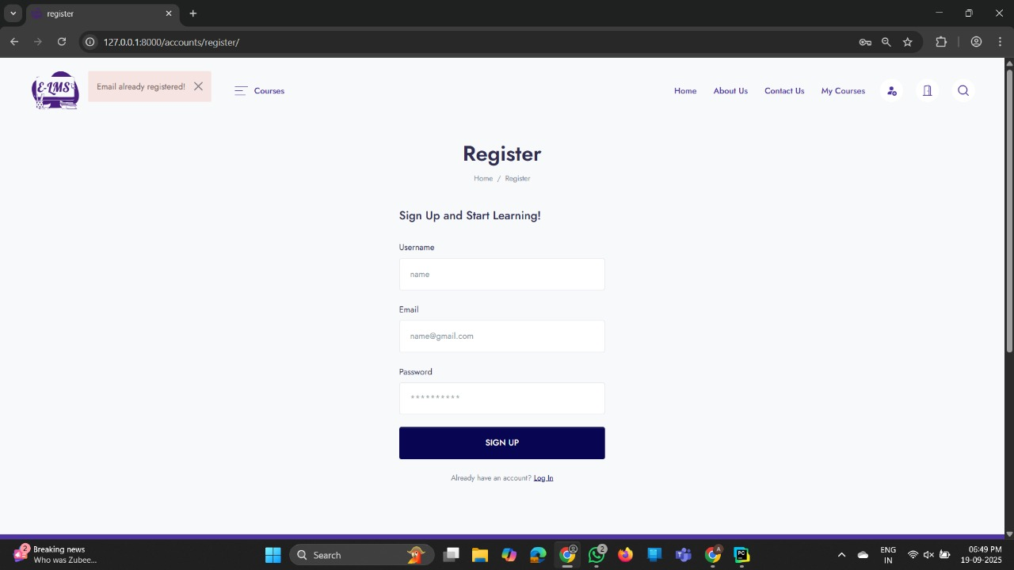

* LOGIN:

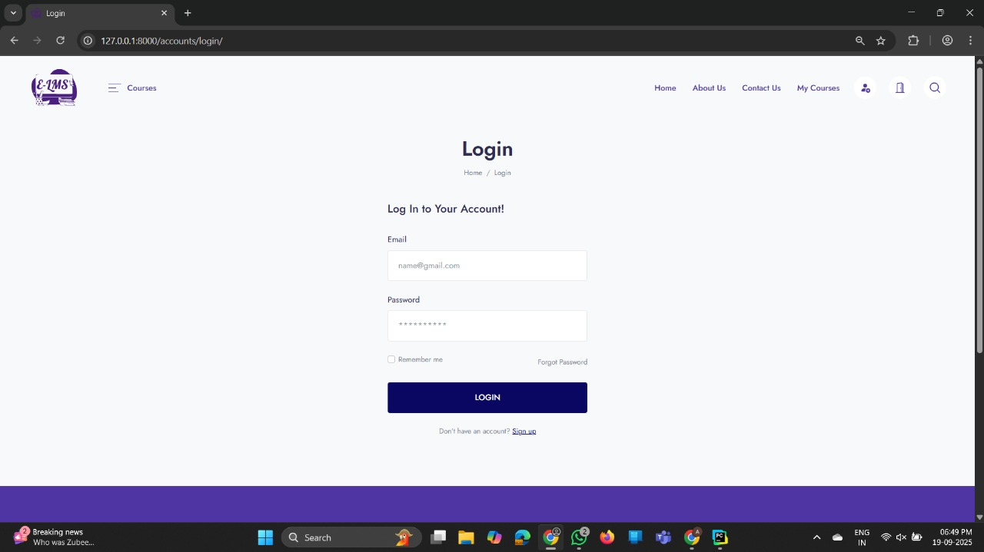

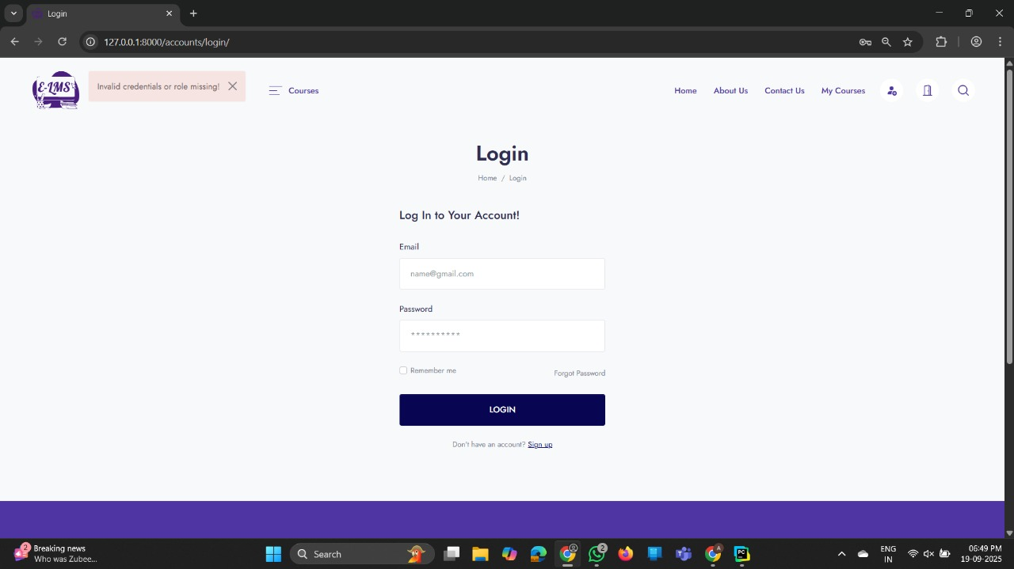

* RECOVER PASSWORD:

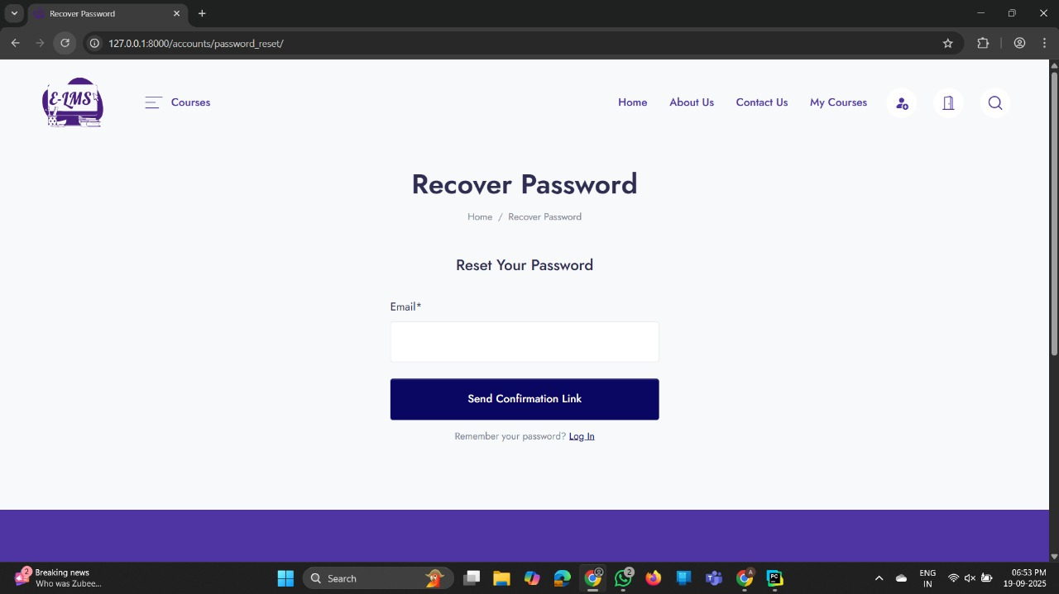

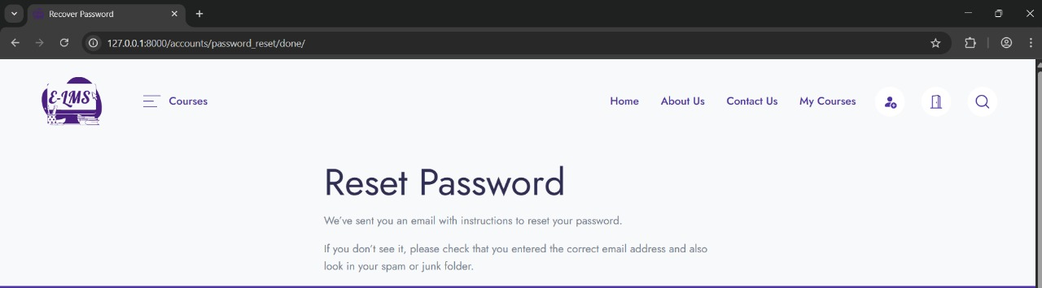

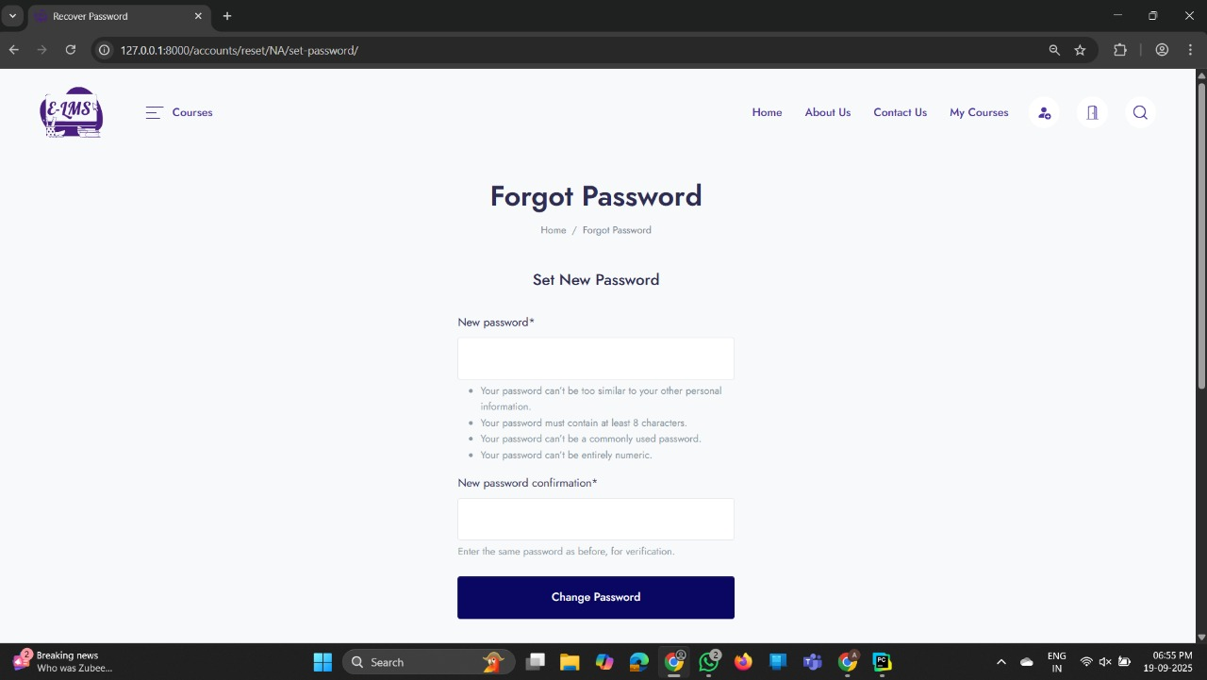

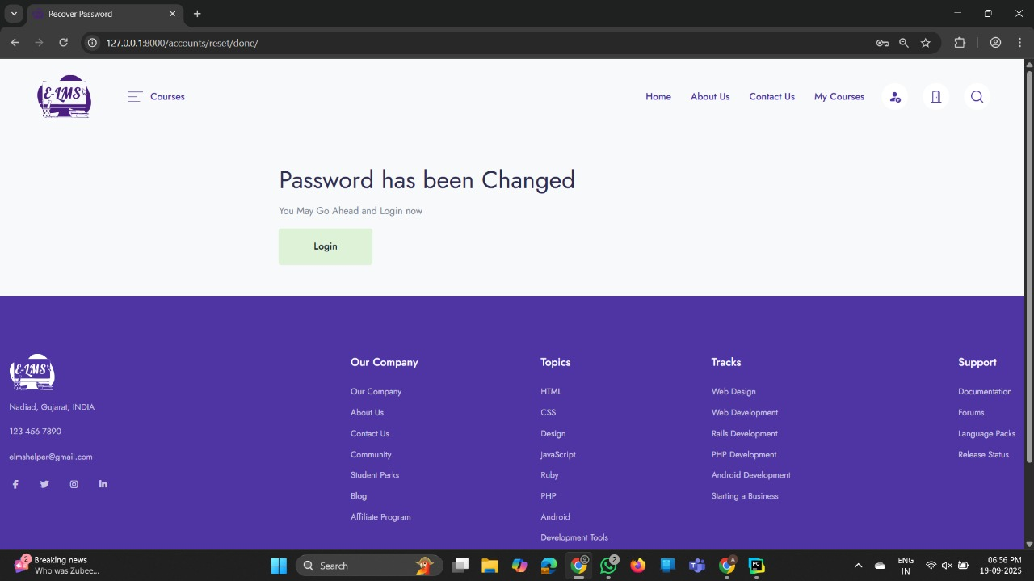

* ALL COURSES (INDEX):

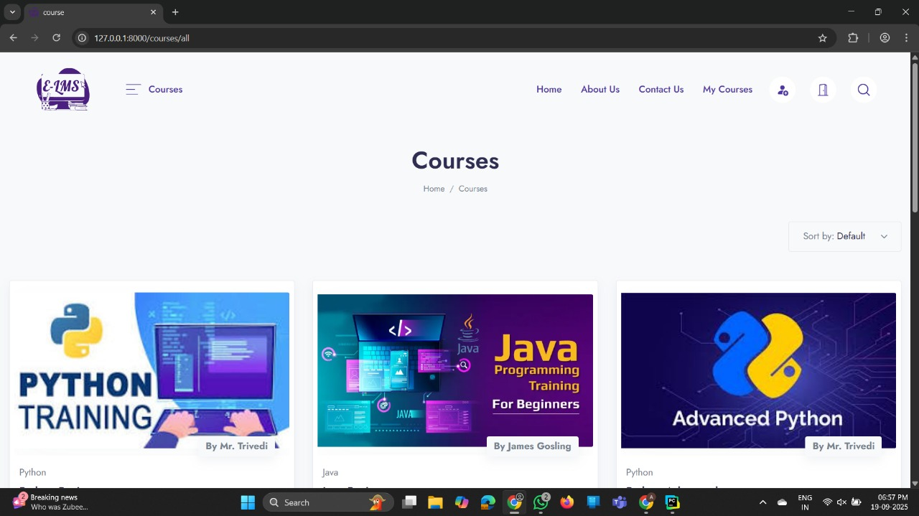

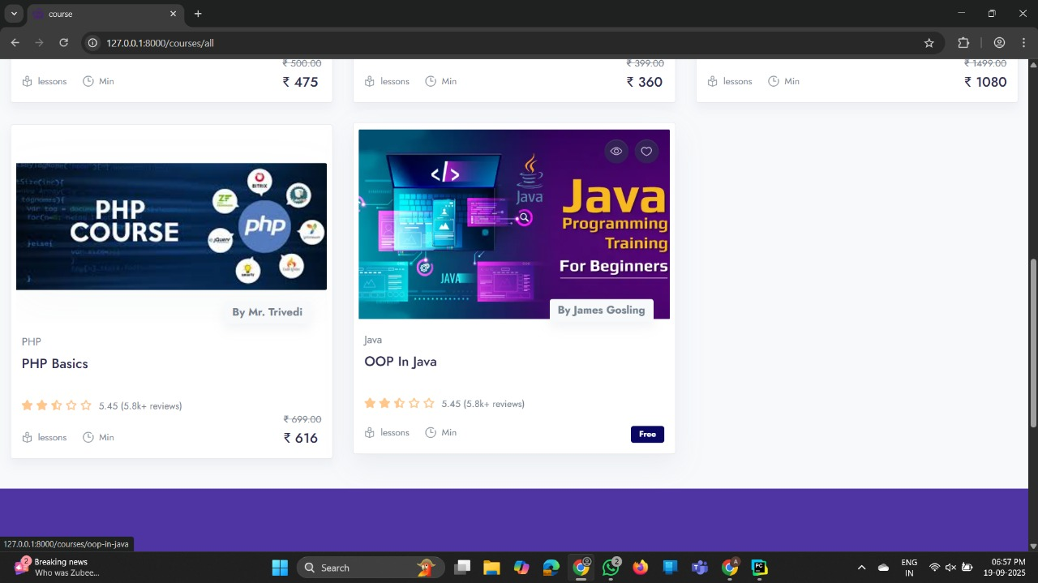

* **ADMIN:**
* PROFILE:

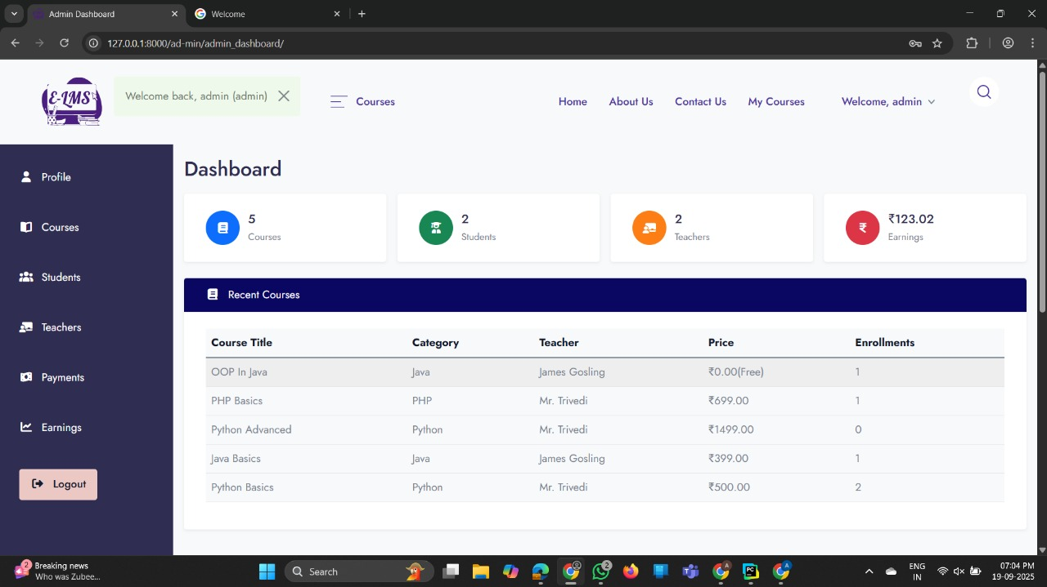

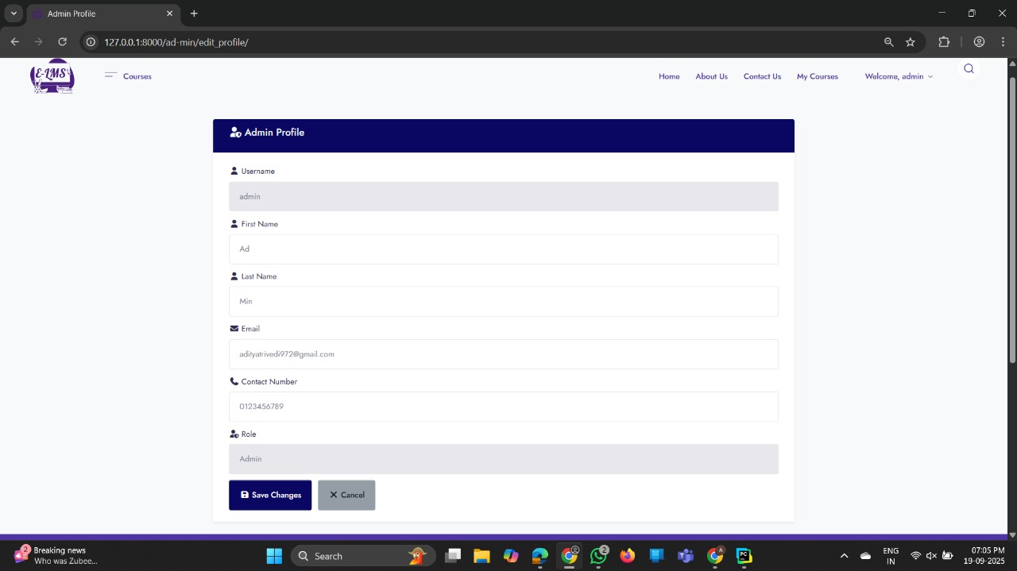

* COURSE:

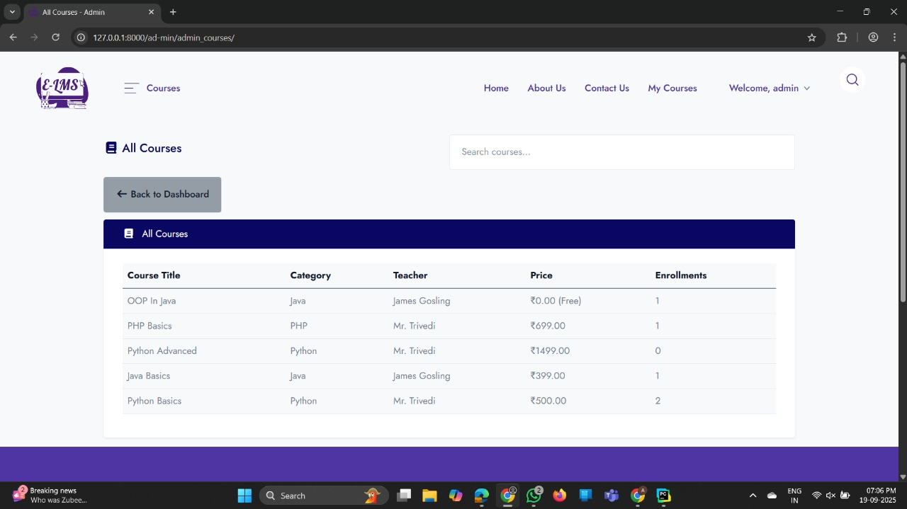

* STUDENT:

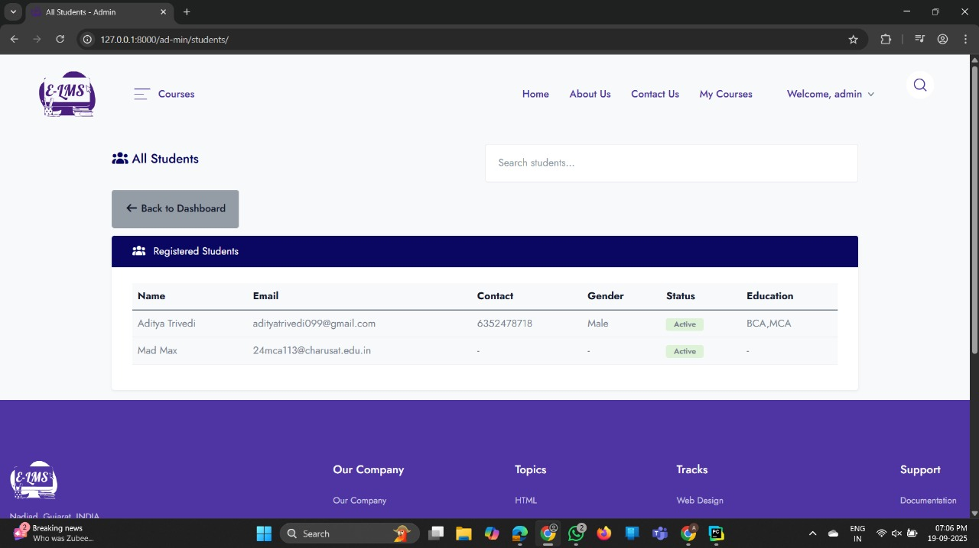

* TEACHER:

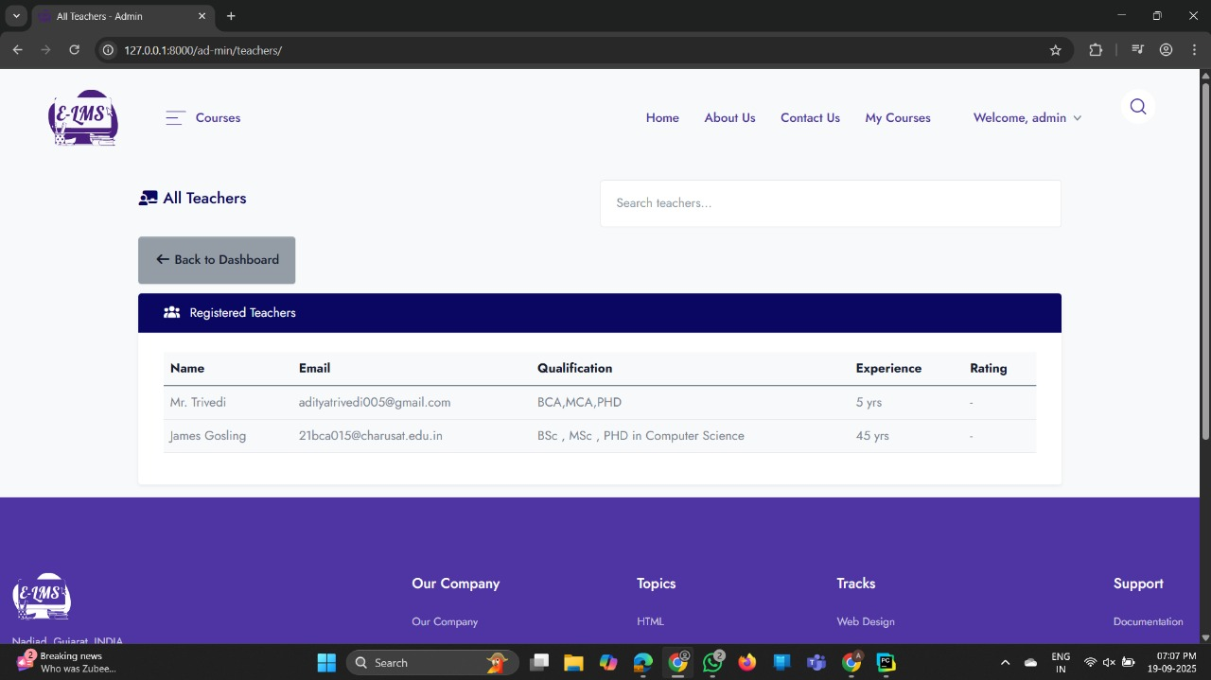

* Dashboard_Payments:

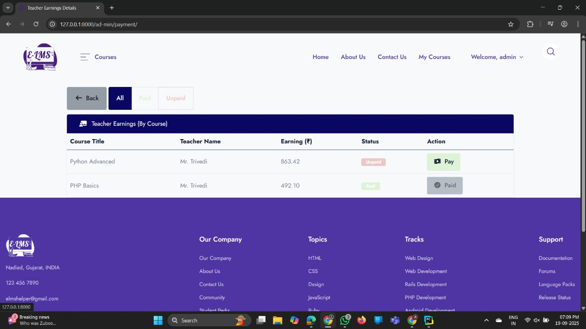

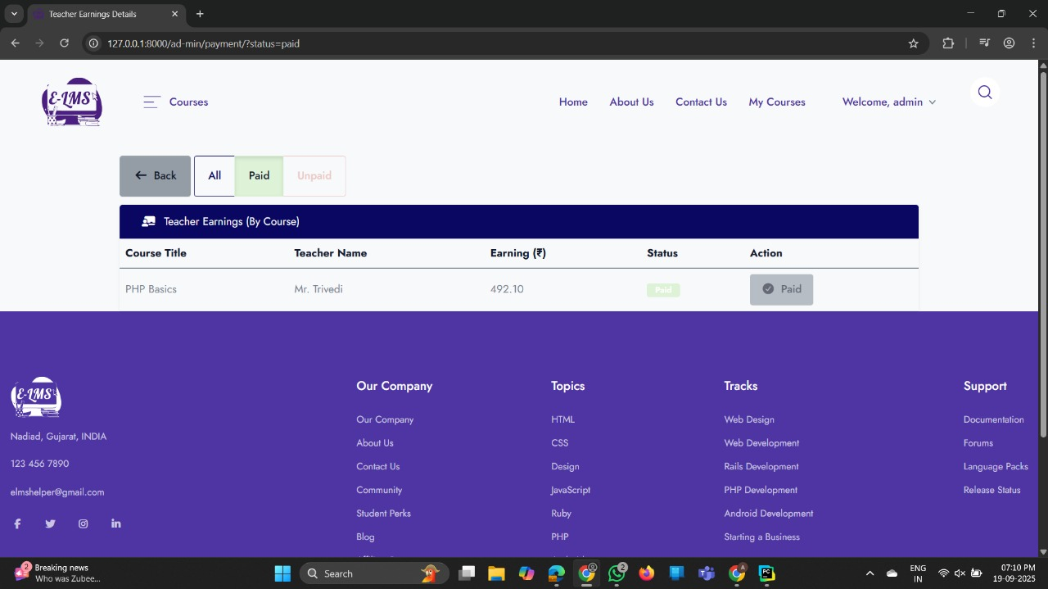

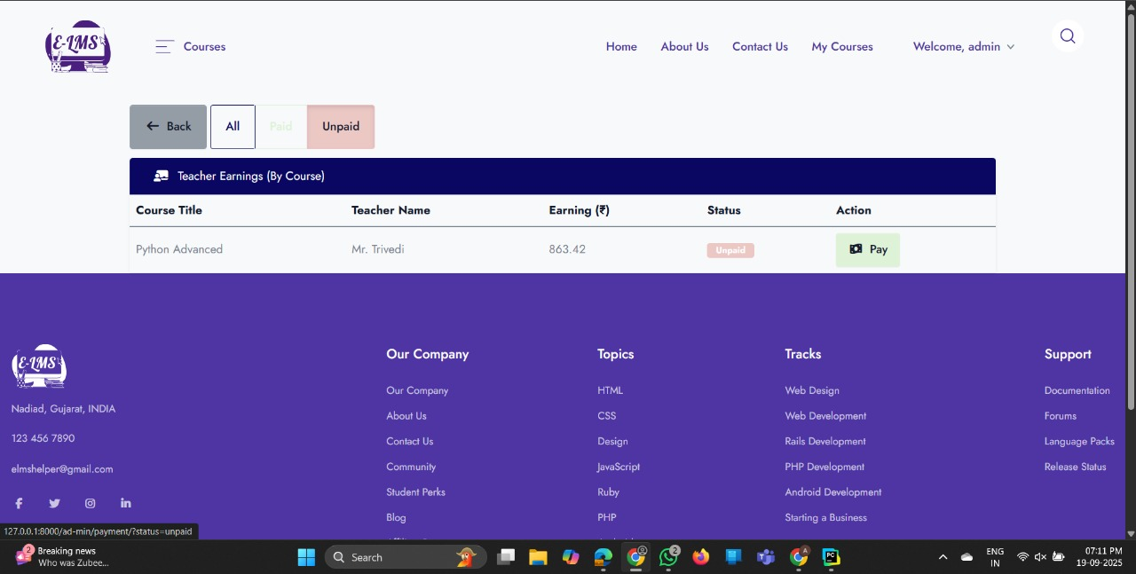

* Dashboard_ Earnings:

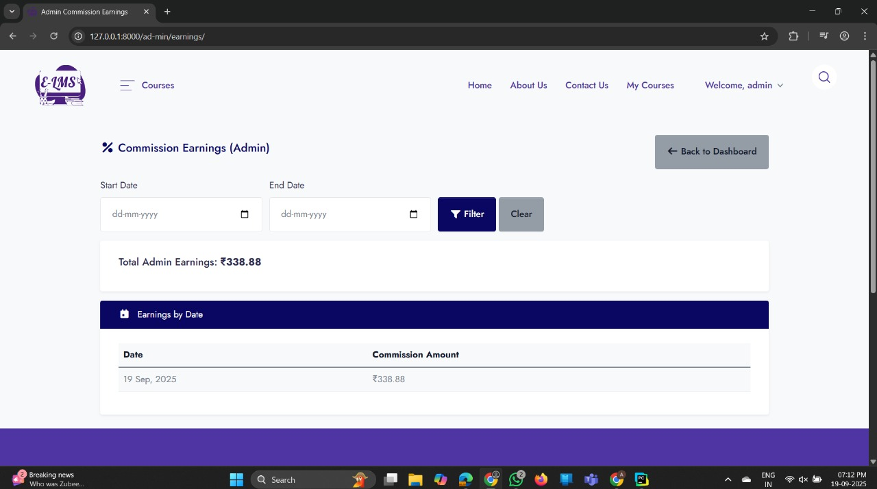

* **TEACHER:**
* DASHBOARD:

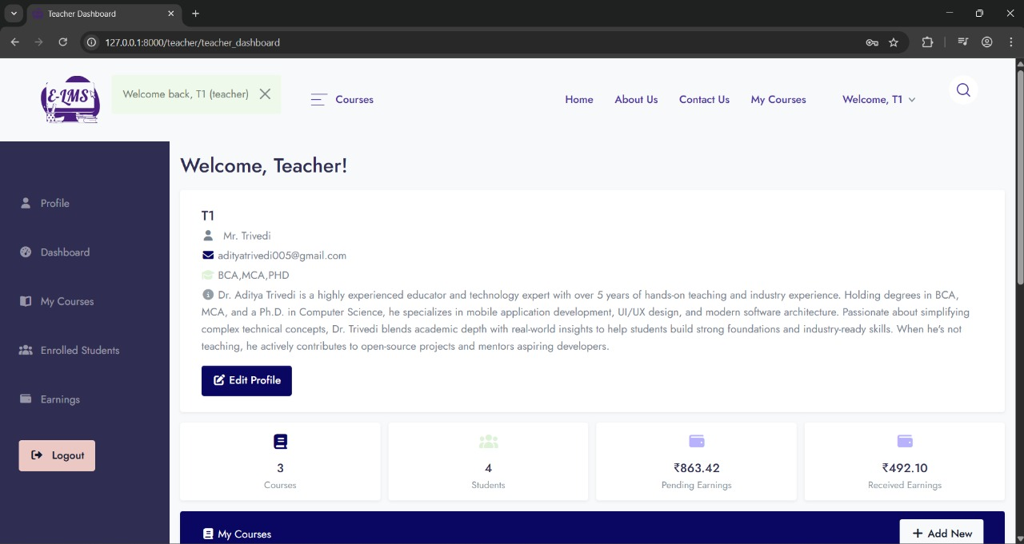

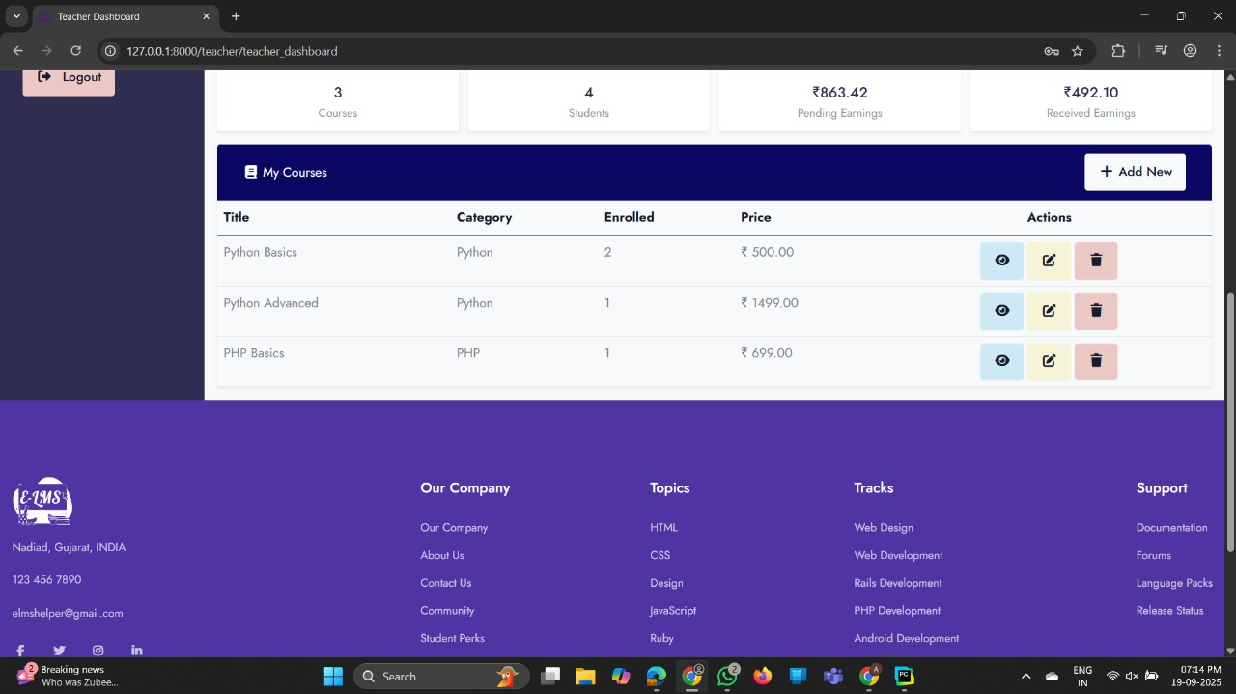

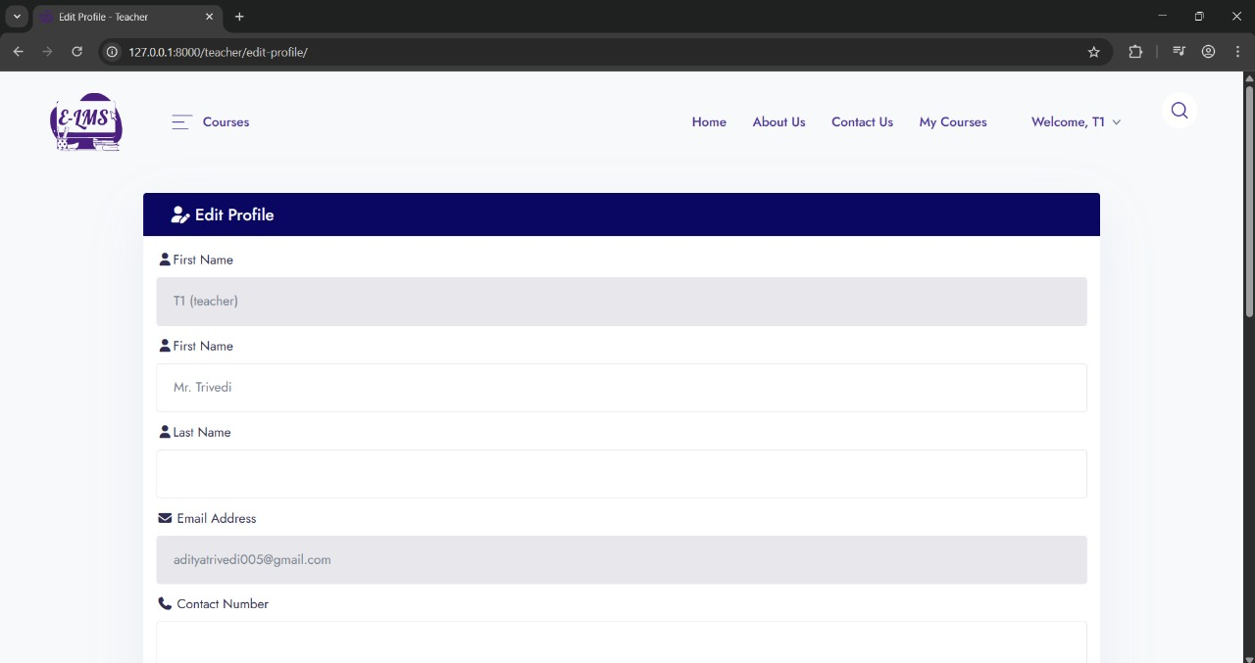

* PROFILE:

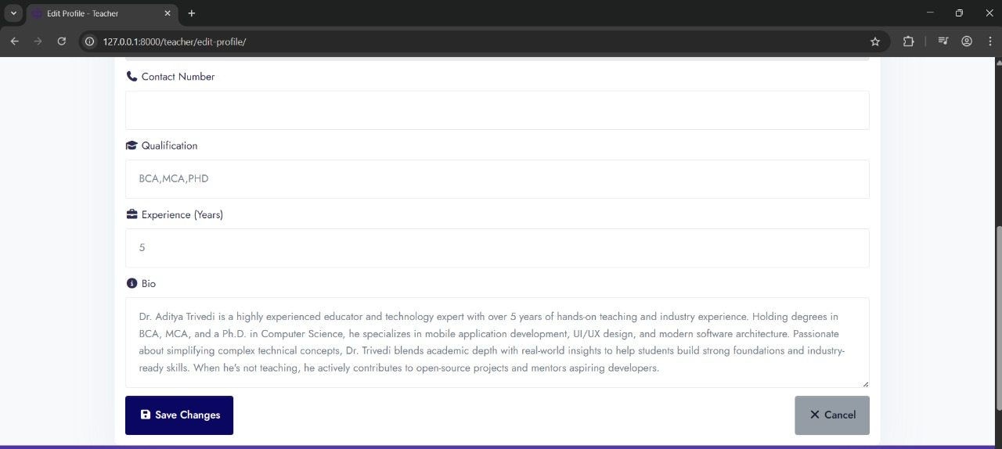

* **STUDENT:**
  + Student_Enrolled_Courses:

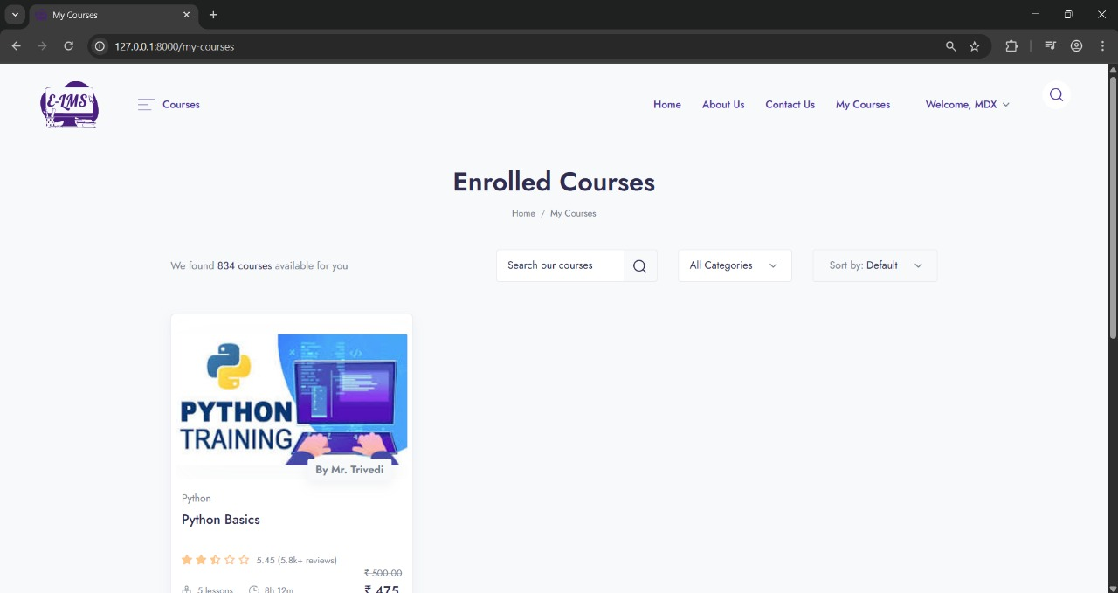

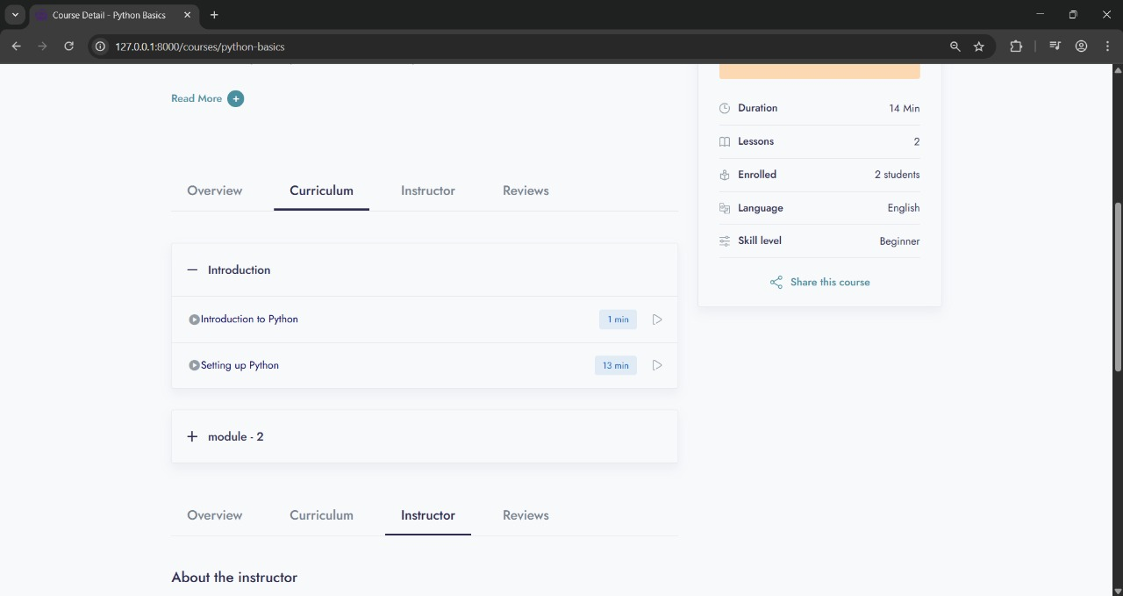

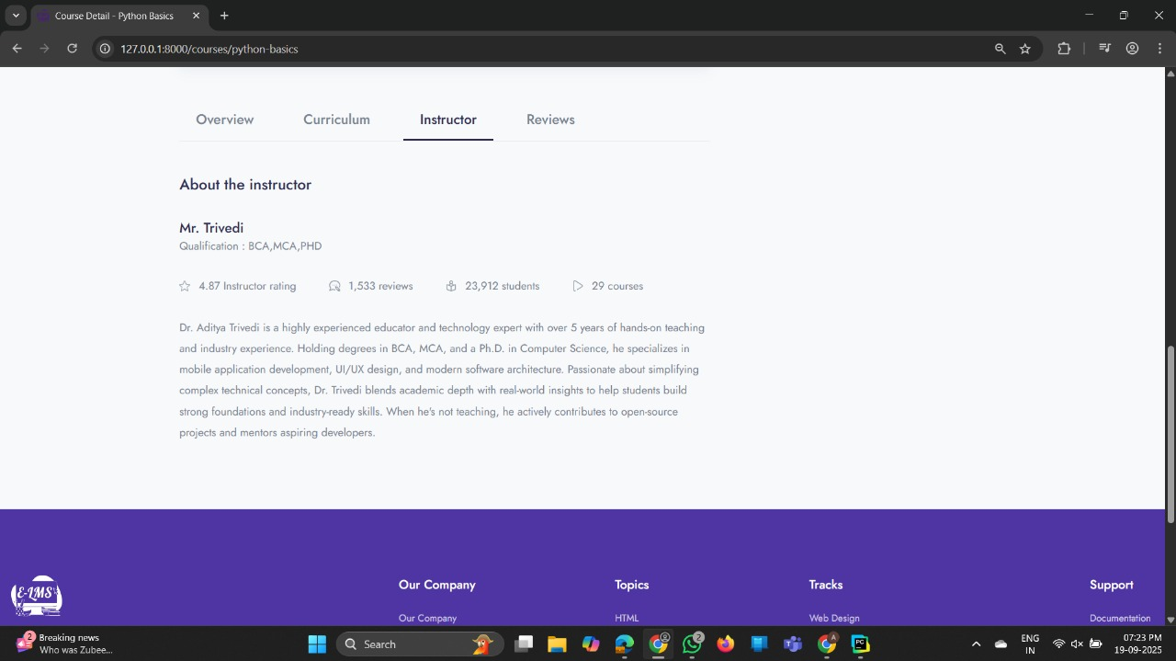

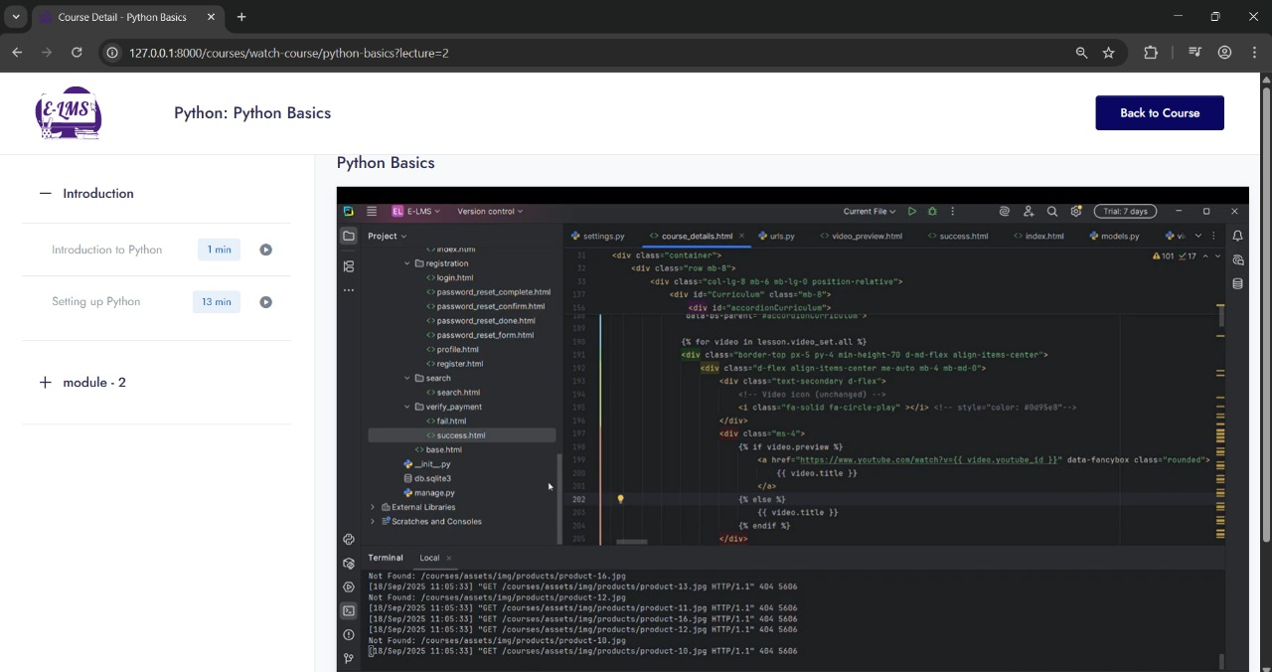

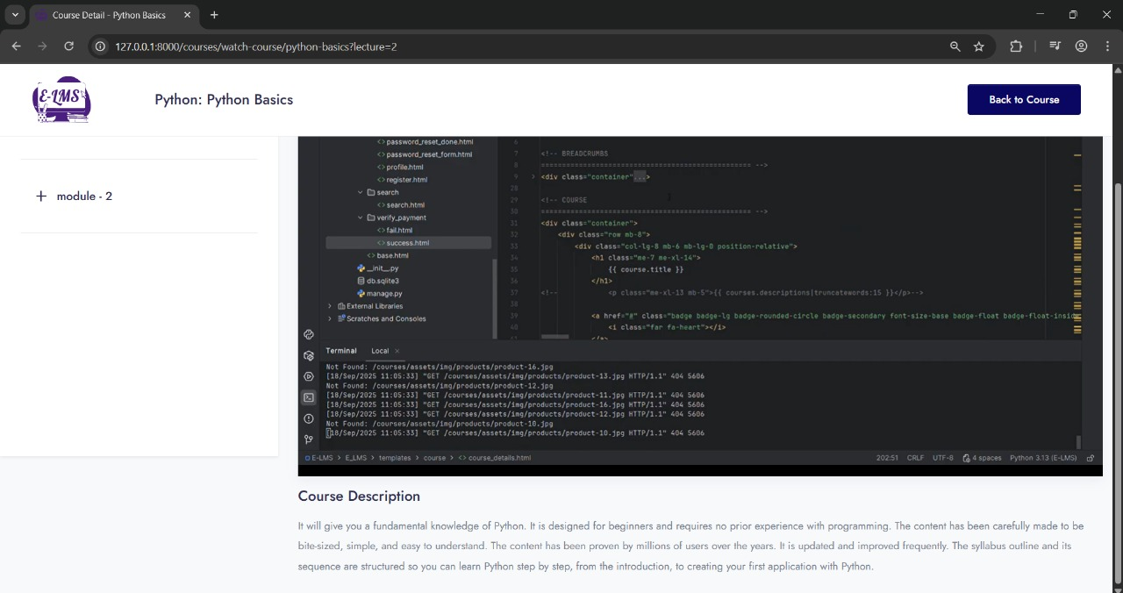



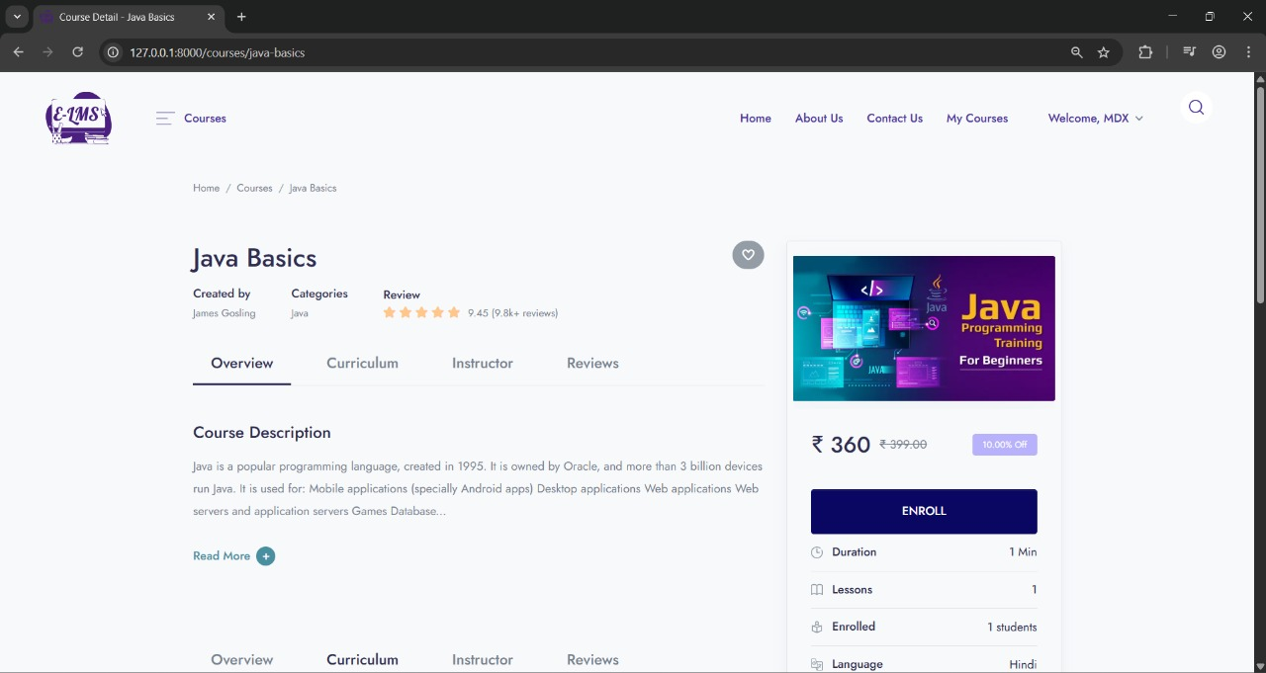

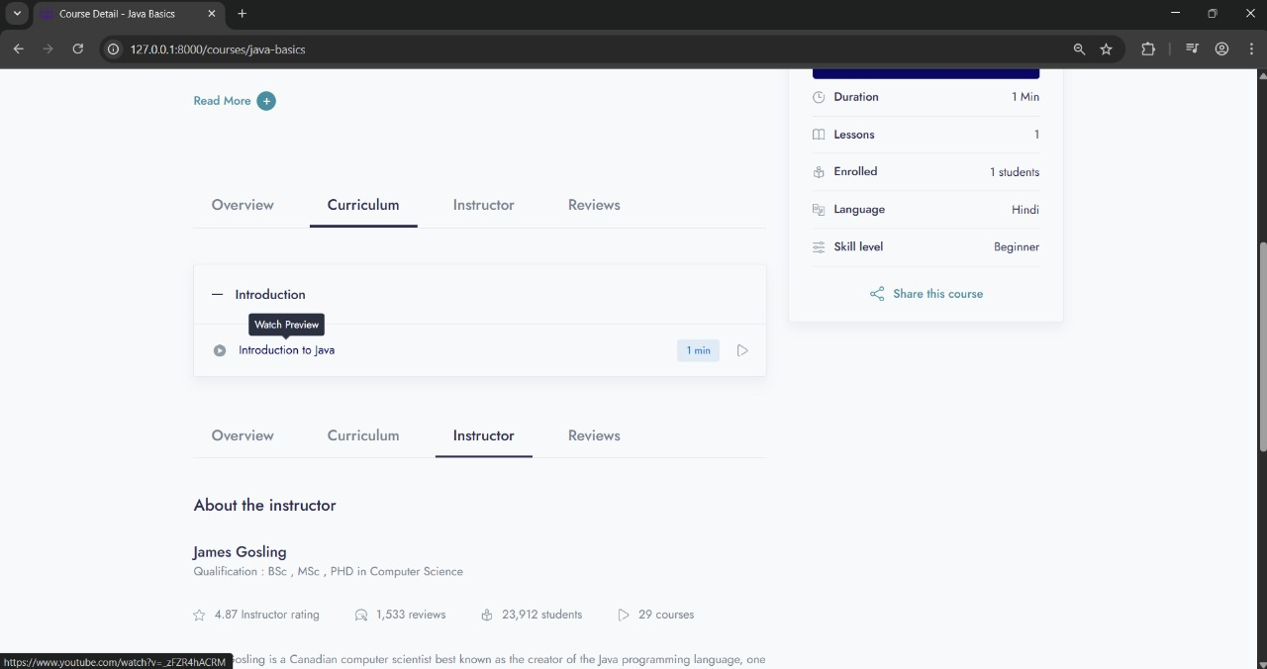

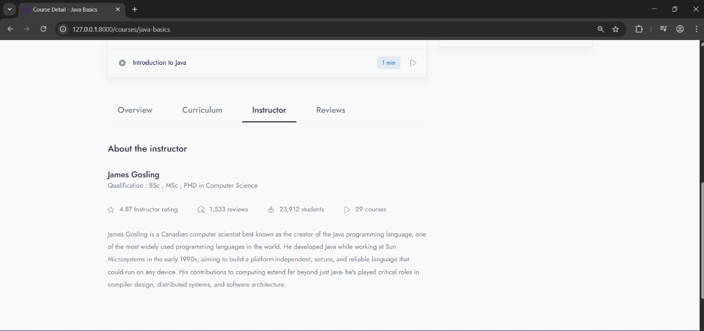

* STUDENT_ENROLLED_COURSE(PREVIEW):

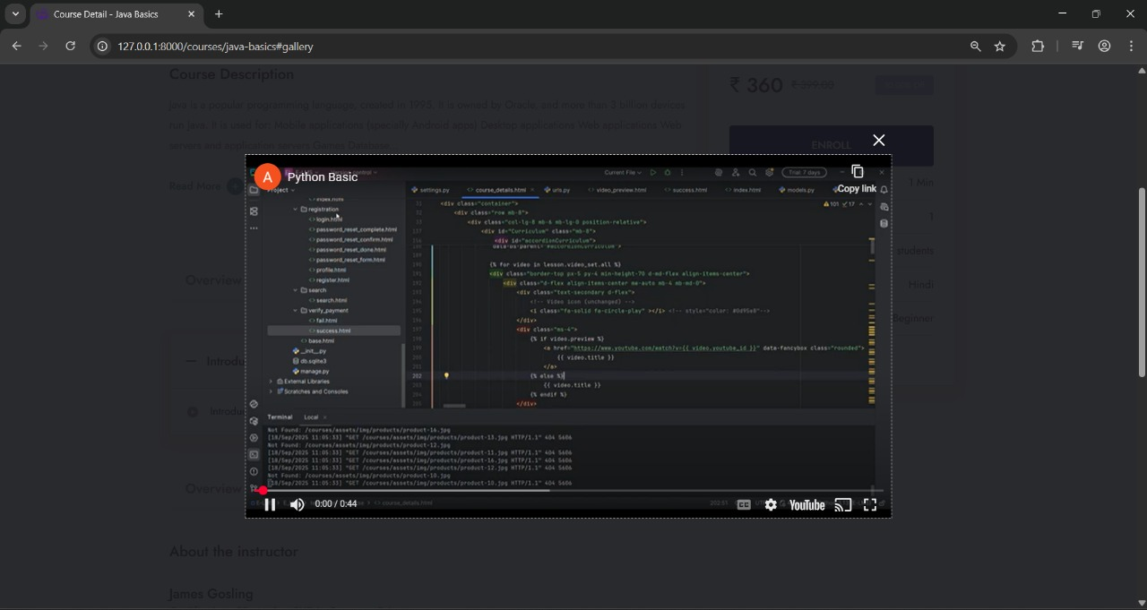

* STUDENT_CHECKOUT:

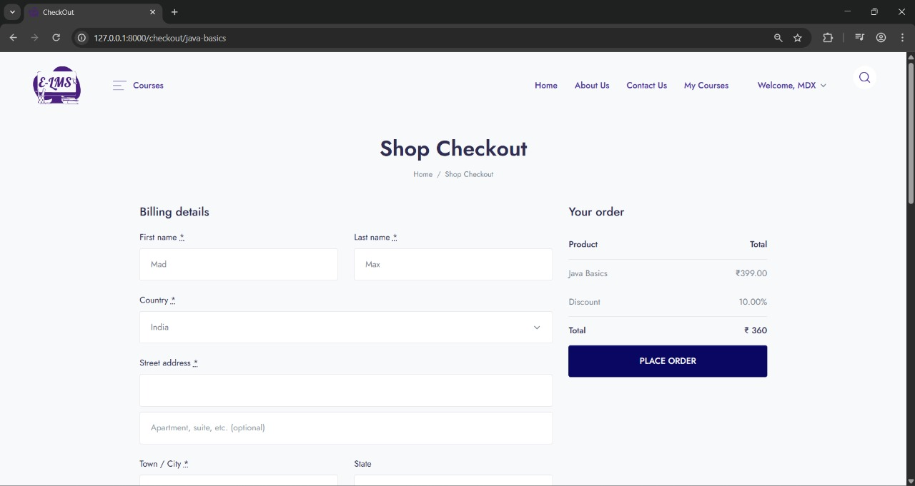

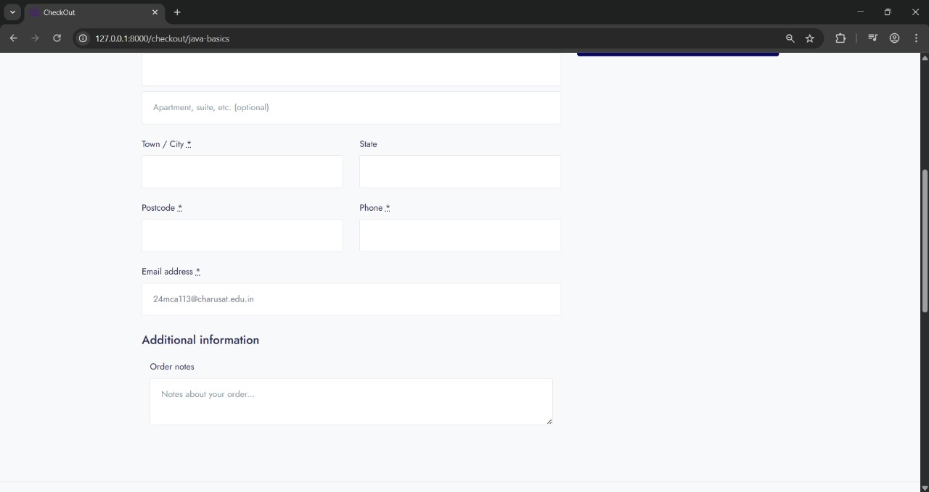

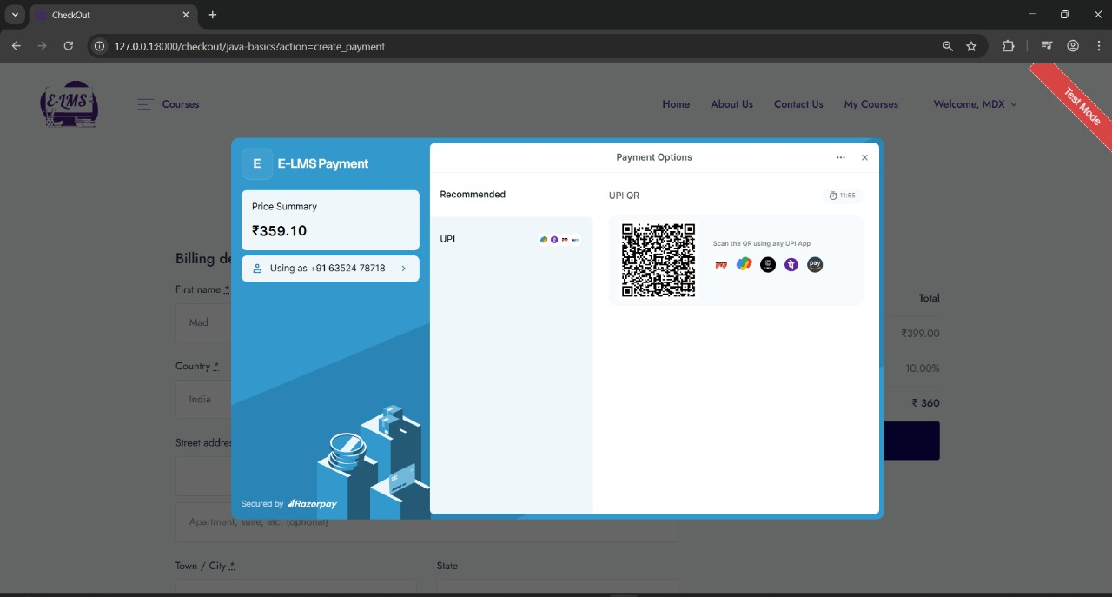

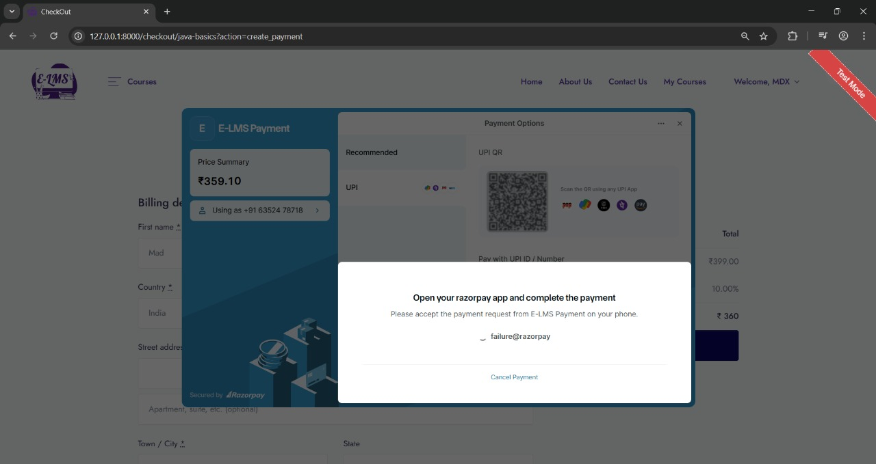

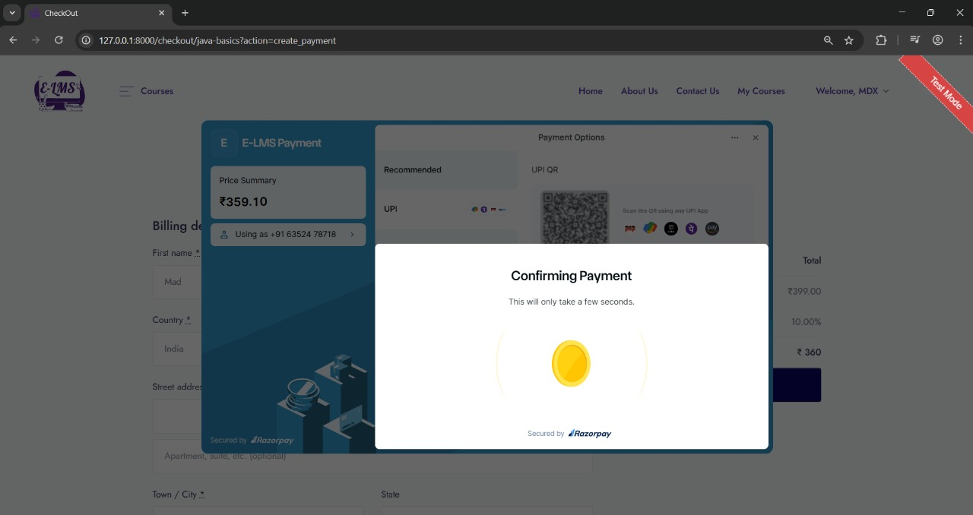

* PAYMENT_FAILED:

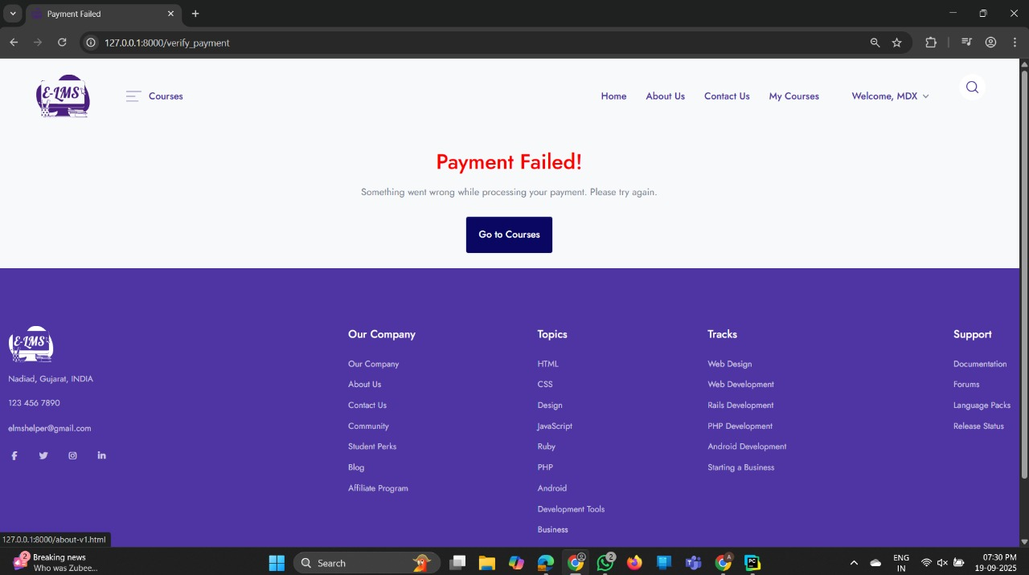

* PAYMENT_SUCCESS:

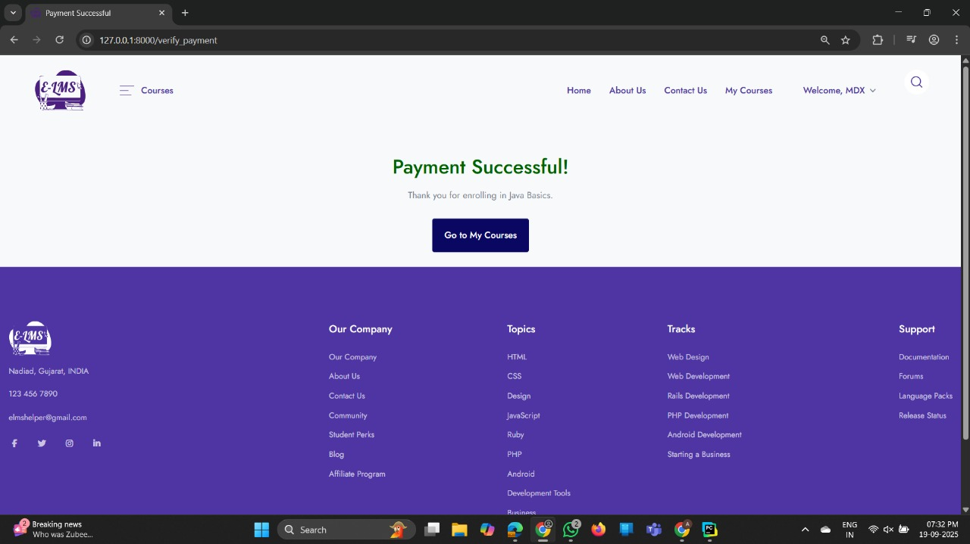

System Testing

* ***System Testing***
* **Test Cases :**

|  |  |  |  |  |
| --- | --- | --- | --- | --- |
| **Test Case ID** | **Module** | **Scenario** | **Steps** | **Expected Result** |
| TC-LOGIN-01 | Login | Valid login | Enter valid email & password → Click login | User redirected to respective dashboard or rediracted page |
| TC-LOGIN-02 | Login | Invalid login | Enter wrong password | Error message: “Invalid username/password” |
| TC-LOGIN-03 | Login | Forgot Password | Click on “Forgot Password” → Enter registered email | Password reset link sent via email |
| TC-REG-01 | Registration | Successful registration | Fill all valid details → Submit | User created & redirected to login |
| TC-REG-02 | Registration | Duplicate email | Enter existing email → Submit | Error message: “Email already registered” |
| TC-COURSE-01 | Course | View all courses | Click “All Courses” | List of available courses displayed |
| TC-COURSE-02 | Course | Enroll in course | Select course → Click “Enroll” → MakePayment(if paid course) | Course added to student’s my course |
| TC-COURSE-03 | Course | Duplicate enrollment | Enroll in same course again | Message: “Already enrolled” |
| TC-PAY-01 | Payment | Successful payment | Select course → Checkout → Enter valid payment | Redirected to “Payment Success” |
| TC-PAY-02 | Payment | Failed payment | Enter invalid card details | Redirected to “Payment Failed” page |
| TC-PAY-03 | Payment | Cancel payment | Cancel during transaction | Status updated as “Payment Cancelled” |
|  |  |  |  |  |
| TC-ADMIN-02 | Admin | View reports | Admin → Dashboard → Payments | Correct earnings displayed |
| TC-ADMIN-03 | Admin | Edit profile | Admin → Edit Profile | Profile updated successfully |
| TC-TEACHER-01 | Teacher | Upload lesson | Teacher → Upload video/lesson | Lesson visible to enrolled students |
| TC-TEACHER-02 | Teacher | View enrolled students | Teacher → Course → Enrolled List | Student list displayed |
| TC-TEACHER-03 | Teacher | Edit profile | Teacher → Edit Profile | Profile updated successfully |
| TC-STUDENT-01 | Student | View enrolled courses | Student → Dashboard → Enrolled Courses | List of enrolled courses shown |
| TC-STUDENT-02 | Student | Play course video | Click on video lesson | Video plays correctly |
| TC-STUDENT-03 | Student | Make payment for new course | Checkout process | Course accessible after success |
| TC-NF-01 | Non-Functional | Performance | Load 1000 users simultaneously | System handles load without crash |
| TC-NF-02 | Non-Functional | Security | Try SQL injection in login | System rejects & logs attempt |
| TC-NF-03 | Non-Functional | Compatibility | Open site in Chrome, Firefox, Edge | UI works correctly on all browsers |
| TC-NF-04 | Non-Functional | Usability | Check responsiveness on mobile | Layout adjusts properly |

Future enhancement

* ***Future Enhancement***

**1. Quiz and Assessment Module**

* Implement a robust quiz/MCQ system with features such as:
  + Timed quizzes
  + Auto-evaluation and grading
  + Instant feedback and result generation
  + Question banks and randomization
* Helps assess student understanding and track progress.

**2. Live Class Integration**

* Integrate APIs like **Zoom**, **Google Meet**, or **Jitsi** for real-time virtual classrooms.
* Features may include:
  + Schedule management
  + Attendance tracking
  + In-app notifications for upcoming sessions

**3. Assignment Submission & Evaluation**

* Add functionality for students to submit assignments in various formats.
* Enable teachers to review, give grades, and provide feedback digitally.

**4. Certificate Generation**

* Automatically generate and provide downloadable course completion certificates.
* Include QR codes or verification IDs for authenticity.

**5. Advanced Analytics & Dashboards**

* Provide teachers and admins with insights such as:
  + Student performance analytics
  + Course popularity
  + Engagement statistics
* Use visual tools like charts and graphs for better interpretation.

**6. In-App Chat & Discussion Forums**

* Enable real-time chat between students and instructors.
* Add threaded discussion forums for courses to enhance peer learning.

**7. Gamification Elements**

* Introduce badges, leaderboards, and achievement points to encourage student participation and completion rates.

**8. Multi-Language Support**

* Expand accessibility by supporting multiple languages for course content and UI elements.

**9. AI-Based Recommendations**

* Implement machine learning algorithms to suggest:
  + Relevant courses to students
  + Suitable teachers for specific subjects
  + Personalized learning paths based on performance

**10. Admin Notification System**

* Set up automated email and SMS notifications for:
  + Course enrollments
  + Payment confirmations
  + System updates

bibliography/reference

* ***References***
* **Web References :**
* [www.youTube.com](http://www.youTube.com)
* www.razorpay.com
* [www.w3schools.com](http://www.w3schools.com)
* [www.bootstrap.com](http://www.bootstrap.com)
* [www.fontawesome.com](http://www.fontawesome.com)

THANK YOU ✌